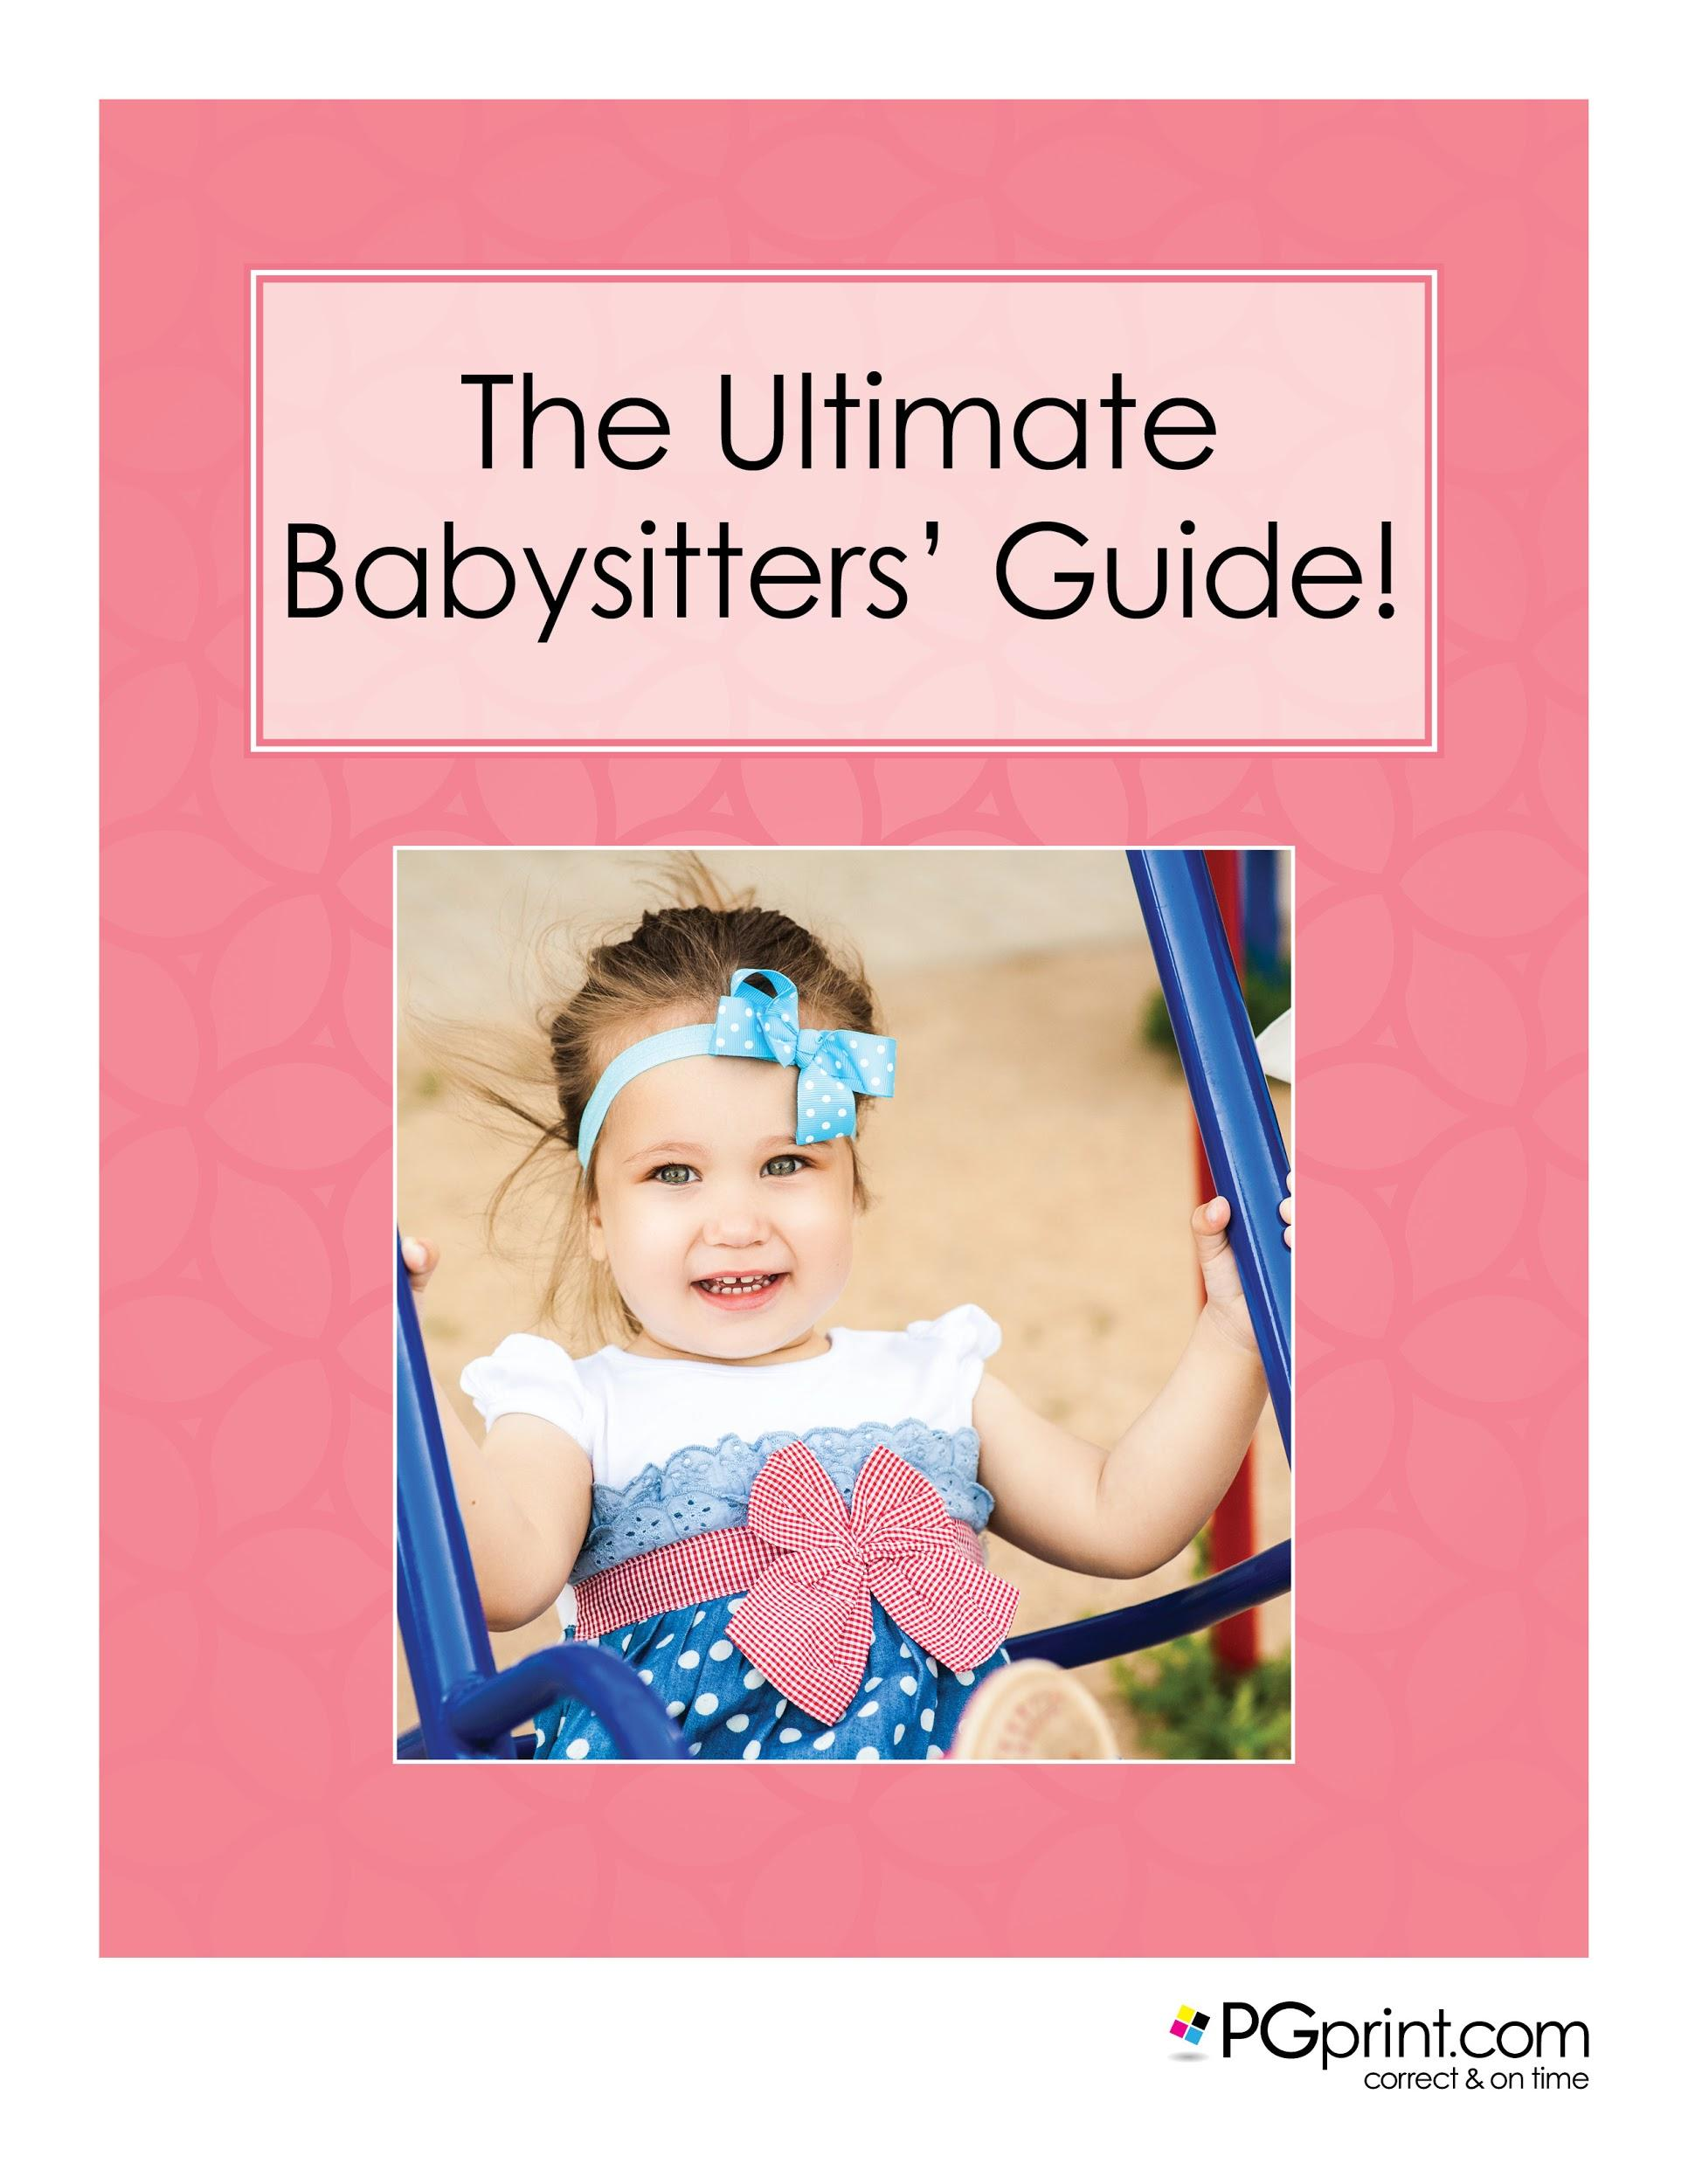

Terms of Use

Acceptance of Terms of Use

Please read these Terms of Use carefully. These Terms of Use govern your access and use of this Site. By accessing or using this Site you agree to be bound by these Terms of Use and to any additional guidelines, restrictions, or rules that may be posted in connection with specific sections or services of this Site. All such additional posted guidelines, restrictions, or rules are hereby incorporated by reference into these Terms of Use. Piedmont Graphics reserves the right to make changes to this Site and to these Terms of Use at any time without prior notice. You should review these Terms of Use each time you access this Site.

You also agree that we may provide all legal communications and notices to you electronically by posting them on our website or, at our election, by sending an e-mail to the e-mail address you provided to us when you registered at our website. You may withdraw your consent to receive communications from us electronically by contacting customer care. However, if you withdraw your consent to receive our communications electronically, you must discontinue use of your account.

Copyrighted Materials for Limited Use
This Site contains graphics, photographs, images, document layouts, artwork, text, fonts, music, software tools, and other information (referred to herein as “Content”). This Site and all Content are the copyrighted property of Piedmont Graphics, Inc., and/or its subsidiaries (referred to herein as “Piedmont Graphics”) or the copyrighted property of parties from whom Piedmont Graphics has licensed such property. All rights in this Site and its Content are reserved worldwide. It is strictly prohibited to retain, copy, distribute, publish, or use any portion of the Content except as expressly allowed in these Terms of Use. Piedmont Graphics reserves the right to add to, delete from, or modify any part of Content at any time without prior notice.

Table of Contents:

Terms of Use
Acceptance of Terms of Use
Copyrighted Materials for Limited Use
Table of Contents:
Foreword:
About PGprint.com
Our Pre-Built Business Printing Packages Packages
Please call 1.888.288.7518 for more information
Our Print Samples
Cheap Printing Services
Chapter 1. Starting Your Babysitting Business
When it Comes Time For Filing Taxes
Chapter 2. Developing a Business Plan
SAMPLE Basic Babysitting Business Plan
Mission Statement:
Objectives:
Services:
Customers:
Strategy:
Chapter 3. Child Care Basics
Chapter 4. Certification, Licensing & Education
Chapter 5. Insurance and Legal Matters
Chapter 6. Gaining Experience and References
Chapter 7. Establishing Pricing
Chapter 8. Handling Business Revenue & Expenses
Chapter 9. Advertising Your New Business
Babysitter Flyer Templates
Babysitter Postcard Templates
Babysitter Business Card Templates
Babysitter Brochure Templates
Chapter 10. Dealing With Potential Clients
Common Parental Roadblocks and Concerns
Chapter 11. Top Resources for Babysitters
Chapter 12. Other Babysitting Ideas and Related Markets
Chapter 13. First Aid and Emergency Situations
Bandaging:
INTERNAL BLEEDING
Bibliography

Foreword:
With most parents today opting to go back to work full time, there is a need to find reliable and reputable child care help. If you are reading this, chances are you are looking to profit from that need, and this guide is meant to help. If you are wanting to turn your babysitting hobby into a career, or simply make more money for the work you do, the tips and tricks, along with the supporting material found in The Ultimate Babysitters’ Guide are guaranteed to help.

There are many centers that offer such services, but a discerning parent would wisely research the center before actually making a commitment to send his or her child there. Places that offer child care, which encompasses the essence of safety, health, and the promotion of physical, emotional, and cognitive skill should be seriously considered as a requirement and a necessity, and not just an advantage. You, however, have all of this and the ability to have a personal touch and relationship with your charges and their parents.

About PGprint.com
At PGprint our motto says it all: Printing online, correct and on time. We take this pledge to heart. We check every file before custom printing, and we print each and every project individually. This allows us to check and adjust color, trim, and other variables, and this attention to detail sets us apart from other online printers. We offer exceptional customer service, quick turnaround, customer pick-up, and a 100% satisfaction guarantee!

Our amazing line of products includes postcards, brochures, menus, flyers, folded cards, and so much more, all available in a variety of papers, finishes, and custom sizes. We offer quality products and unbeatable prices, as well as design tools and templates for every need. This means everyone can create the unique materials they need to promote their business. Stay a step ahead of your competition with PGprint.com

Our Pre-Built Business Printing Packages
PGprint offers business printing packages along with quality printing services. Contact us for details. We take the time needed to understand everything about your business, and help formulate new ideas that include creating a logo and branding theme, marketing, including direct mail, and a powerful website that will work for your business and more importantly serve your customers.

If you know exactly what you want, or are just generating ideas, our business packages will help you evaluate your specific printing needs. Request a sample package today: Perfect for any aspiring professional babysitter. https://www.pgprint.com/printing-packages/

Please call 1.888.288.7518 for more information

Our Print Samples
Thank you in advance for considering PGprint.com as your printing partner. We understand the value of choosing the right printer, and we are happy to provide a small sample book of the papers we offer, as well as a sample postcard so you can see the quality of our work. Please visit us at https://www.pgprint.com/printed-samples/ and complete the form to request your paper sample book today.

Please Note: Currently, we only mail to the US.

Monthly Specials
We know business printing and we are here to meet your printing needs, so don’t settle for big names and low quality. You are more than just an order number to us! We have the biggest variety of top-quality, printing inventory that can be customized to your exact needs.
Even though our services include cheap printing services, do not mistake value for lack of quality. All orders are guaranteed correct and on-time. Please visit us at https://www.pgprint.com/promotions/ for current discounts and specials.

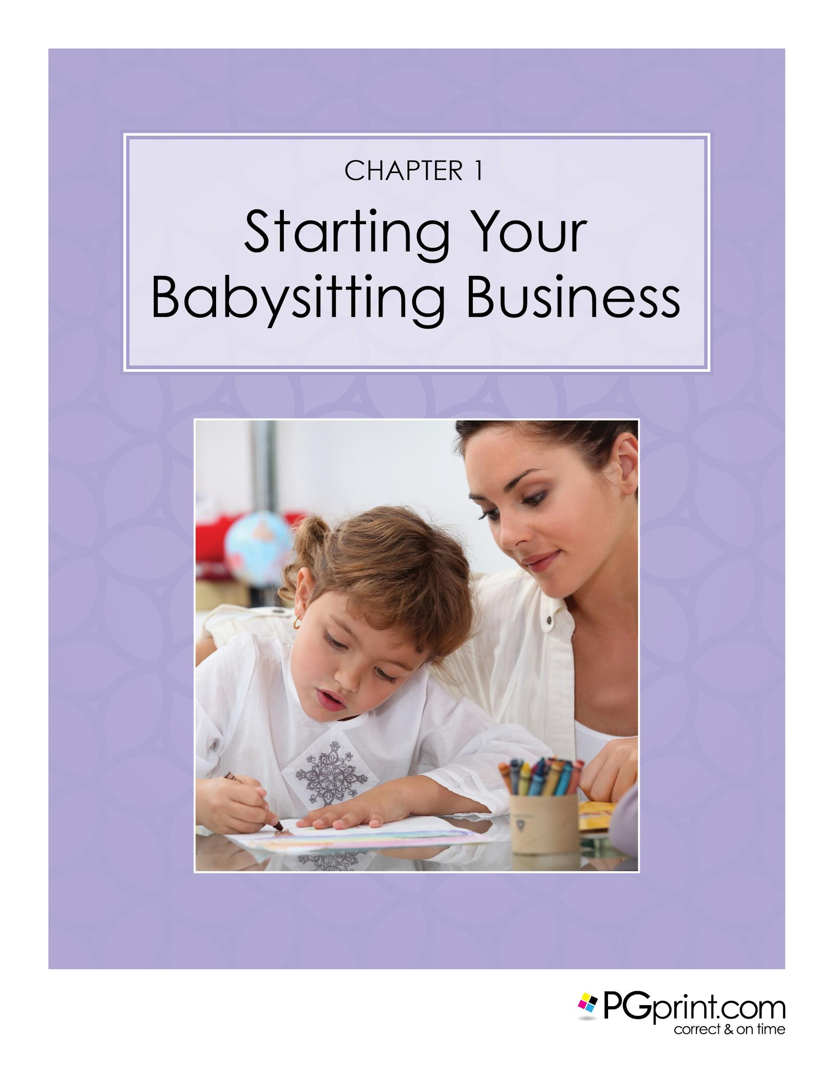

Chapter 1. Starting Your Babysitting Business

In order to meet the monthly financial costs of raising a family, most two-parent families must both work to be able to afford the cost of living and put food on the table. In addition, there are many single parent families as well as all types of blended families. No matter what type of family you are, if you have children, you will most likely be in need of good quality child care! The good news is that this means that there is a high demand for babysitters.

Whether you are already a babysitter who has regular clients, or you are looking to start your own business, babysitting is an excellent way to earn money. Teenagers, college students, and retirees looking for additional income are all perfect candidates for becoming a babysitter and small business owner. One major attraction of starting your own babysitting business is that your start up costs can be very inexpensive. Some additional perks of a babysitting business is that it is generally recession proof, it is needed year round, and can be planned around your schedule. This allows for flexibility for your own life! As a business owner, you would also be learning valuable skills that may be of benefit to you in a future job or new career. A home-based business can provide you with money saving tax breaks at tax time, or can be run as a small cash-based business.

This guide is intended to provide information and resources for babysitters of all ages and all skill levels. From the novice or beginner to the experienced babysitter, our guide will get you started or help you maintain and grow your babysitting business so it is a safe and rewarding experience for everyone involved. When finished, you should have all the tools and resources you need in order to launch and grow your business.

According to the Internal Revenue Service you do not have to file taxes for income under $5,000. Since the average pay rate of a starting babysitter is around $10 an hour, you would have to work for 500 hours or almost 12 weeks before you have to worry about the government. That is plenty of time for you to get up and running and learn what else you will need to do. Do not let worrying about taxes or forms stop you from getting started!

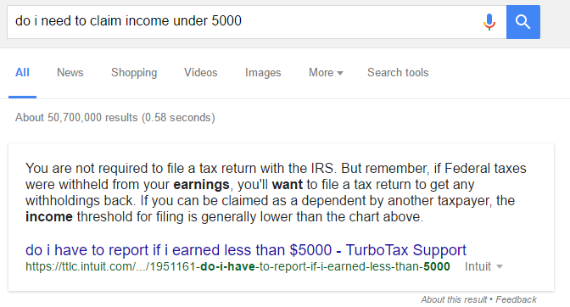

When it Comes Time For Filing Taxes
Not only do you not need to worry about any taxes until you earn your first $5,000 - when it does come time to file taxes, there are methods of doing so that will not cost you a dime. In fact, most tax filing programs do not charge for basic Federal tax submissions. Below are a few you can select from.
- H&R Block http://www.hrblock.com/online-tax-filing/free-online-tax-filing/
- Turbo Tax https://turbotax.intuit.com/
- Free Tax USA http://www.freetaxusa.com/
The IRS also has plenty of information you will want to read through. This is great reading when you have your charges tucked into bed and you are waiting for parents to come home. DO NOT ignore your responsibility to learn about your business and your obligations. It takes work to build a business, and it is up to you and you alone to do it right the first time.
You can read more about filing taxes for your business below. All IRS links and information is taken from and linked directly to the IRS.gov website. https://www.irs.gov/tax-professionals/e-file-providers-partners/electronic-filing-options-for-business-and-self-employed-taxpayers.
- Employer Identification Number
An Employer Identification Number (EIN), also known as a federal tax identification number, is used to identify tax reports to the IRS.
- Business Taxes
The form of business you operate determines what taxes you must pay and how you pay them.
- Estimated Taxes
Federal income tax is a pay-as-you-go tax. You must pay the tax as you earn or receive income during the year. There are two ways to pay as you go: withholding and estimated taxes.
- Employment Taxes for Small Businesses
If you have employees, you are responsible for several federal, state, and local taxes. As an employer, you must withhold Federal income tax withholding, social security and Medicare taxes, and Federal Unemployment Tax Act (FUTA) taxes.
- Self-Employment Taxes
The self-employment tax is a social security and Medicare tax for individuals who work for themselves.
- Your business may be required to file information returns to report certain types of payments made during the year.
- e-File Form 940, 941 or 944 for Small Businesses
Learn your options for e-filing form 940, 941 or 944 for Small Businesses.
- Filing Past Due Tax Returns
Before you decide not to file your tax return on time or not pay all of your taxes when they are due, consider this.
- Reporting Payments to Independent Contractors
If you pay independent contractors, you may have to file Form 1099-MISC, Miscellaneous Income, to report payments for services performed for your trade or business.
- Deceased Taxpayers - Probate, Filing Estate and Individual Returns, Paying Taxes Due
Information to help you resolve the final tax issues of a deceased taxpayer and their estate.
Reporting Information Returns
Taxes are one of those things that we all have to contribute to in order to maintain a safe society. But, in order to grow your business and be able to pay taxes in a way that is affordable, you will need a robust business plan.

Chapter 2. Developing a Business Plan

No matter how large or small you would like your business to be, simple organization can be a key to your success whether you are just starting or you are looking to expand your current business. Developing a business plan can be as simple as a one page document that outlines goals you set for yourself, or it might be extremely detailed and include vision and mission statements, expenses, and budgets and cost projections. Think of it as a roadmap or a checklist for your ideas and the steps you need to take in order to start your business off on the right foot. There is no right or wrong way to develop a business plan! This is YOUR business, and you should use what methods and tools with which you are comfortable.
If you decide that you would like to write a business plan, there are many websites available that offer free templates for all types of businesses, large and small. Just by doing a simple internet search and looking at a few business plan templates, you may find that you are opening yourself up to new thoughts and ideas for your business and its success. The website www.growthink.com has an excellent article on reasons for having a business plan, most of which apply to almost any type of business.

Here is a perfect example from the www.growthink.com website that directly pertains to why a business plan is beneficial for anyone starting a babysitting business, “To better understand your competition.”

Creating the business plan forces you to analyze the competition. All companies have competition in the form of either direct or indirect competitors, and it is critical to understand your company's competitive advantages” (Kennedy, 2008). Depending on where you live, you may have considerable competition. Understanding how you can distinguish yourself from your competitors can be of great help as you build your new business. As you read through each chapter you will gain additional knowledge and ideas that can assist you if you decide that creating a business plan is an important step to creating or building your successful business.
Micha Paramitha has a great example of a business plan focused on child care on www.slideshare.com that might help you get started.

SAMPLE Basic Babysitting Business Plan
Any successful business starts with a business plan. A business plan includes a mission statement, objectives, services, customers, and strategy. Please create a business plan with the format below:

Mission Statement:

My Mission Statement is:

Objectives:

My Objectives are: (your goal for babysitting for example earning income, gaining experience, providing a service to your community/family, etc.)

Services:

- What days are you available:
- What is the longest amount of time you would babysit:
- What is the shortest amount of time you would babysit:
- What sets you apart from other babysitters:
- What are things you are willing to do while babysitting:

Customers:

- Some family members I know I could babysit for are:
- Some friends/people in my community I know I could babysit for are:

Strategy:

- Your hourly rate:
- What “marketing” tools (business cards, networking, etc.) will you use:
- What are other ideas you have for building a babysitting business:

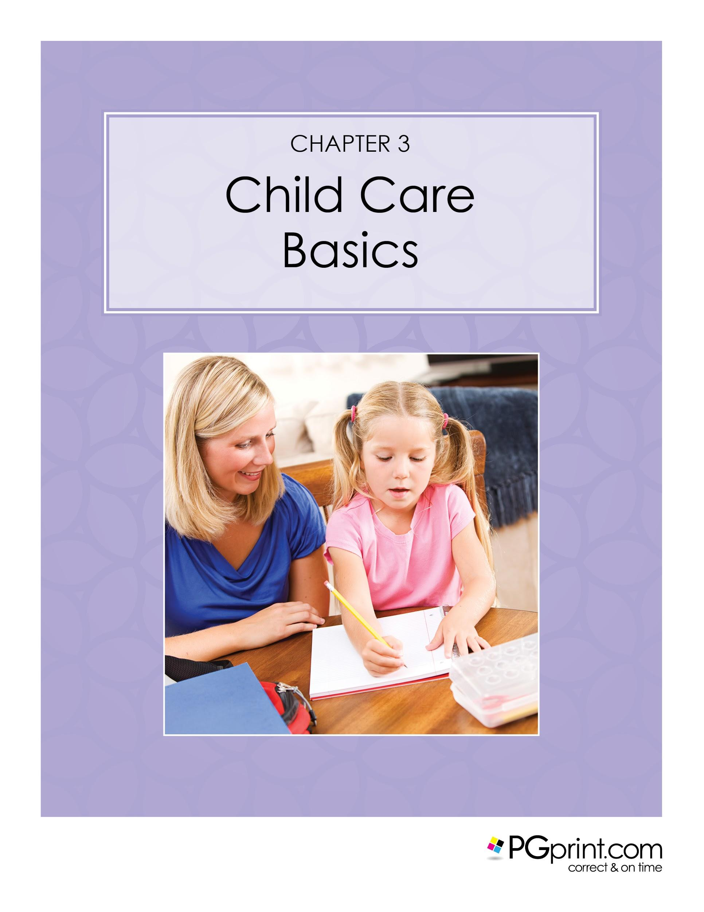

Chapter 3. Child Care Basics
There is no doubt that working with, and managing children of all ages can be extremely challenging at times, no matter how old they are! Parents, family members, and caregivers of children have all experienced the frustration of coping with a child, even on the best of days! When babysitting a child we would all like to feel that we have made the child feel safe, comfortable, and happy. It is just as important that you, as the caregiver, feel safe, comfortable, and happy as well. If you are new to babysitting and child care, take the time to think about what age range of children you would comfortable caring for. Be honest with yourself. Keep in mind your current skills as they pertain to caring for a child. Tasks such as changing diapers, bathing, and warming up a baby bottle may not be something that you are comfortable with yet, so keep these things in mind before you accept a job babysitting an infant. If you are just starting out as a babysitter it is okay to turn down a job with which you do not feel comfortable.
Safety is the number one priority when babysitting a child. There are many types of courses and training that include babysitting safety that are offered in most areas or even online. Babysitting courses will help you to learn the skills needed for your babysitting job or business. These will be covered in more detail in a later chapter.

Safety training is imperative, and by using a safety checklist you can ensure that you are helping to provide the safest environment possible for your charges. Children of all ages will always attempt to “try” something or take advantage of a sitter when the usual parent or caregiver is not around. No matter what facility or home you are in while doing your job, the safety precautions and problem areas do not change.

Some of the most dangerous areas for a child in any home or business are the kitchen, bathroom, garage or workshop, stairs, and any body of water such as a swimming pool or pond. Depending on the location of your prospective job, there may be additional areas to which you should pay attention. First and foremost, make sure that you know where children are at ALL times. It is very easy to get distracted for even a moment, which is all that it takes for an accident to happen. By creating and utilizing a safety checklist, both you and your client can feel comfortable knowing that you have both identified any and all problem areas. During your interview, take the time to do a walk-through with new clients in their home. They will appreciate your attention to safety and detail, and can also alert you to any other possible problem areas or concerns they may have regarding safety. Don’t ever be afraid to ask questions during an interview with prospective clients! There are many generic forms and templates available online that you can download and customize to fit the needs of your business and clientele.

Next to safety, information is another top priority when accepting a babysitting job. If you are accepting a local babysitting job, there is probably some information you may already know about how to contact local authorities. In the case of any emergency, it is always best to have a written information and instruction sheet that lists all important emergency and contact numbers for Police, Fireman, Ambulance, and Poison Control, just to name a few. A parent may also want you to have their Physician's phone number and preferred hospital. Contact numbers for each parent or caregiver(s) as well as other responsible local family or friends should be included.

Always make sure that all of the information is up to date if they are a repeat customer. Even though you may not be required to fix a meal during your job, other important information such as known food or medication allergies is very important to note. We do have templates available for download that will allow you to fill in the blanks for all of the important information that you will need when accepting a babysitting job. An information sheet should be filled out by the parent or caregiver for each child for whom you will be responsible. In the event of any type of accident or emergency, remain calm and remember that you have documented information and protocol to utilize if necessary.
Safety and information are very important to laying the groundwork for a successful babysitting job, but just as important is your interaction with the child or children in your care. Children of all ages love to be entertained, and you will find that by creating the right kind of fun and creative atmosphere you will enjoy your job as much as the children enjoy you! A happy child means a happy parent/caregiver and most likely repeat business for you! In this age of technology and video games, make sure that you understand if there are any limitations or rules that have already been set at their home. Many parents would prefer personal interaction between you and the child especially if they are younger. Remember to have fun, but be firm and clear on what the house rules are that have been given to you. If you have taken a job that includes babysitting a teenager, your interaction with them may be limited depending upon their personality and any specific information the parent or primary caregiver has outlined as to what their expectations are of you with that particular child. Many teens prefer to be left alone, but this does not mean unsupervised.

Probably the least favorite topic for any babysitter is how to discipline a child. Every family has its own set of rules regarding how to deal with children who act out or disobey. Be sure that you thoroughly understand how your client would like you to handle discipline for each child as it may often differ, even in the same home depending on a child's age or needs. With most children, being fair but firm is the best way to handle discipline issues.

Most parents that have ever had to hire a babysitter would agree that “The best sitters take time to prepare age-appropriate activities for the children that they are sitting” (Babysitting games, 2010-2012). I still have memories of the many babysitters that my parents employed during my childhood. The babysitters that I remember most are the ones that took the time to engage with me and my siblings and always had creative activities ready at a moment's notice.

Chapter 4. Certifications, Licensing, and Education

Once you have decided that a babysitting business is the right choice for you, it is extremely important that you begin educating yourself about anything and everything that has to do with child care. This can and should include a basic course on babysitting, CPR, and first aid. Even if you have decided not to include infants and young toddlers as customers, you should still be knowledgeable and preferably certified to administer basic life saving measures to a child of any age. Even experienced babysitters who have not completed any type of formal training should make this a priority. Your experience, qualifications and completed training will all help to determine the price that you can charge for your services. Be sure that the training you sign up for is from a reputable source that can document or certify your completion and passing of each course.

There are many free babysitting courses available online to choose from as well, but many do not provide any type of certification of completion. The American Red Cross is an excellent source of information for education and training for babysitters. Their website states “8 in 10 surveyed parents said they would pay more for a trained babysitter who holds Red Cross babysitter certifications” (American National Red Cross, 2014). For Red Cross classes that cannot be located near your place of residence, they now offer several online courses in addition to their traditional classroom style training. Both the classroom style and online courses provide a printed or printable certification once you have completed and passed the course. Red Cross certifications are valid for two years. Access the Red Cross website at www.redcross.org to find a complete list of training courses and certifications near your location by typing in your zip code. They offer a multitude of courses from babysitting basics to advanced childcare and much, much more.

Here is a list of just some of the types of training and educational courses that will benefit you in your babysitting business:

- Babysitting Basics
- Advanced Child Care
- CPR for Infants and Children
- Water
- Safety
- Lifeguard Certification
- First Aid Course
- Fire Safety
- Nutrition Basics for Children
- Choking First Aid

Local hospitals, the YMCA, fire and police stations, and your local community colleges are also great places to get additional information from in regards to any other specific types of training in which you are interested. Always remember to make sure that you will be able to provide documentation of your education and training that you have successfully completed. Your clients will also be happy to know that you are serious about your business. Any continuing education courses that you plan to attend will certainly add to your appeal as a prospective babysitter to most families. Keep in mind that many certifications that you may receive could have expiration dates, as courses and training can be changed and updated constantly. Make sure that you continue to keep any of your training up to date by re-obtaining any certifications before they expire.

While you are “in training,” you can still gain some real time experience with children by asking family members, friends, or neighbors that know you if you can play and interact with their children while the parents are present until you feel comfortable with and begin to understand what a parent or caregiver is expecting from you. If you have limited experience with children, older toddlers and school aged children would be a good age to begin with as you start taking babysitting jobs. Don’t be afraid to ask questions! If you know any experienced babysitters they are also an excellent source of information for most questions you may have.

Don’t overlook any special talents or education that you may already be trained in or familiar with, as these can also be considered a plus for a potential client. Specialty areas like arts and crafts, music, photography, fluency in a second language, or culinary talents are an excellent way to distinguish yourself from your competition and help you to keep a child entertained and teach them a new skill at the same time.

As long as it is age appropriate, involving the children that you babysit in your hobbies and passions for a particular activity is one of the best ways to keep children entertained. Your enthusiasm for any activity will certainly make a difference in the way that a child will pay attention, interact with you, and have fun at the same time.

Most states do not require a babysitter to have a license to conduct business, although your state may have a minimum age requirement to be a babysitter. If no current law exist in your state regarding babysitting there may still be guidelines to be followed. Keep in mind, however, that licensing requirements, and laws for babysitting and child care are set by each state individually, and most of the laws that are in place pertain to child care facilities and child care homes. Some states have given the responsibility of setting laws and guidelines for babysitters up to each county or locality. For example, although you may not need a license to babysit a child or children in their own home, your state may require you to obtain a license if state and local governing agencies. The website https://daycare.com/states.html allows you to click on each state to get more information about licensing requirements. Laws and requirements can change frequently so always be sure to keep yourself up to date on current laws and licensing in your state or county regarding your business or babysitting guidelines in general. If you are starting a babysitting business outside of his is an excellent way for beginners to learn not only what age range of the United States, always be sure that you fully understand any legal requirements for your local area.you were to babysit children in your home.

Each state has a different set of rules and regulations governing child care and you can learn more about your state's requirements by contacting your

Chapter 5. Insurance and Legal Matters
All businesses should be aware of and consider any possible legal issues that may arise. This certainly includes proper local and state licensing or certification requirements, but another extremely important matter is the issue of liability. In the unfortunate case of an accident, illness, or injury, who would be held responsible? Depending upon where you are babysitting, in your home or in the home of the child, you may decide that you need to obtain the appropriate insurance.

If you are just starting out as a part-time babysitter that occasionally does babysitting in someone else's home, you probably will not require a separate insurance policy. Babysitting on a part-time basis in your own home may not require a special insurance policy, and in many cases the liability insurance on your current homeowner’s insurance policy may cover any accidents or medical costs that may occur. Always check your with your insurance agent to make sure that you understand what coverage you currently have, and they can assist you in deciding if you may need additional coverage. No matter what your current situation is in regards to your babysitting business or insurance coverage at the present time, the best approach is to speak with a qualified agent who can guide you, so you can make an informed decision on what is best for you and your business. As a smart business owner you will always want to make sure that you protect yourself as well as your client.

When starting your babysitting business you will want to consider how you would like your business to be structured. Many babysitters start as an all-cash business, but may find that if they are growing in size and revenue they want to restructure. There are several options to choose from when deciding on a business structure. Each type of business structure will have its own legal and tax obligations that you will need to adhere to. Many babysitters choose to operate as a sole proprietorship due to its simplicity. Another popular option for a babysitting business is a limited liability corporation, also knows as an LLC. An LLC has advantages that can benefit a babysitting business as it allows your business to be held liable instead of you personally. The U.S. Small Business Administration has an excellent website, www.sba.gov/starting-business, that has detailed descriptions of the different types of business structures as well as information on business laws and financials. If you do decide to to go with a business structure that requires legal documents to be drawn up and filed, there are several online companies that may suit your needs. Companies such as legalzoom.com and incorporate.com are just two of the many reasonably priced ways to set up your company and have your papers filed for you. Do your homework to make sure that you will be receiving the proper documentation and filing for the state where you will be conducting business.

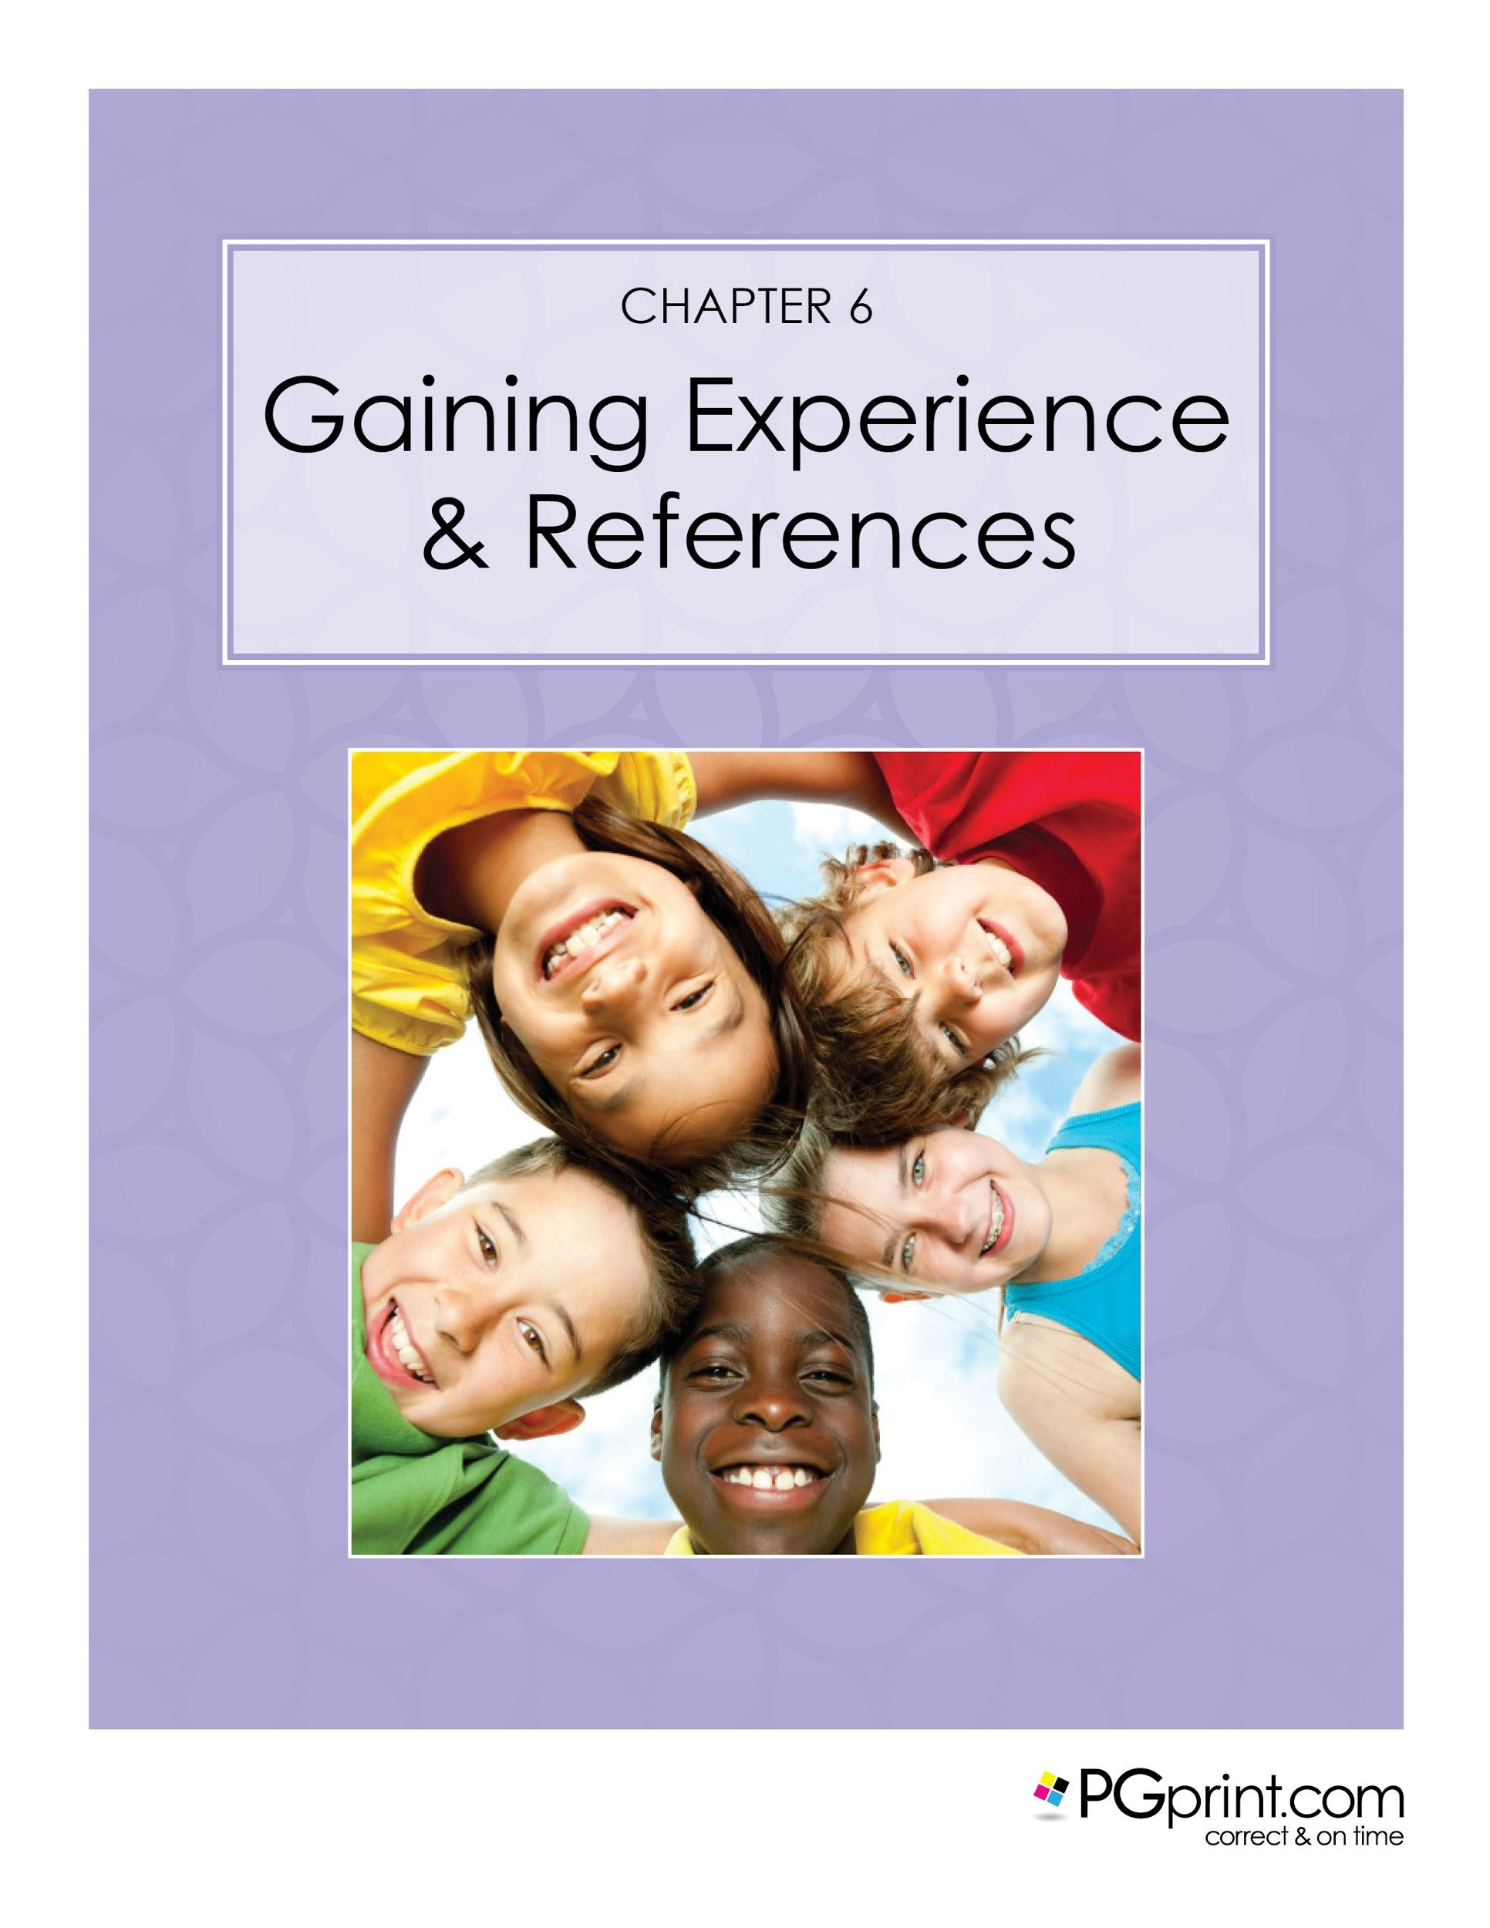

Chapter 6. Gaining Experience and References

Almost all employers and businesses in any line of work will be interested in your experience and references before they will consider hiring you for a position. Babysitting requires that you take care of someone's child, so your experience and good references are of the utmost importance for this type of job or business. Whether you are a young beginner or a well seasoned veteran, presenting yourself in the most positive and professional manner to a prospective client will always work in your favor.

If you are new to babysitting as an income producing job or business you will want to gain as much experience as possible. The first place to start is right at home! For example, do you have younger siblings or relatives that you have taken care of in the past? Family and relatives or people that know you well are the perfect place to begin or continue to gain experience in caring for children. Another excellent way to gain hands-on experience with children is by offering your services as a mother's helper. In most instances, a mother's helper is hired to assist the mother or other primary caregiver with their child or children while they are at home and can still be supervising. This is a perfect opportunity for you to practice your babysitting skills and gain references and a possible future client at the same time. In some cases you may receive compensation for your services as a mother's helper.

Another excellent way to gain experience with children of all ages, no matter what your age or skill level, is through volunteering. Offering your services as a volunteer will allow you to obtain additional experience, as well as prospective clients. Volunteering to work with children can start right in your own backyard by offering to help watch siblings or nieces and nephews at family gatherings, or by assisting a neighbor with their children. For beginners and babysitters that already have some experience with children there is certainly no shortage of volunteer opportunities in your local area that involve working with children of all ages. Here is a list of some places to start looking for volunteer opportunities:

- Church daycare centers
- Local pre-schools and schools after care programs
- Local daycare centers
- Salvation Army youth centers
- Community centers

For a much wider range of volunteer opportunities, an excellent resource is the government website www.serve.gov. You will be able to narrow your search by your city’s zip code and what your area of interest is in regards to volunteering. For example, you may want to use the word “children” in your search or “children & education” which may bring up additional locations and organizations looking for volunteers. Some of the organizations that have been listed on this website include the Girl Scouts of America, Ronald McDonald House, Salvation Army, and AARP youth programs, just to name a few. The sky's the limit when looking for places to volunteer, and you will be gaining excellent experience and giving back to your community at the same time. Gaining experience also means gaining confidence in yourself which will help to propel you forward in your next interview, job, or new business venture.

As you begin your babysitting career or continue to expand your education and experience, remember that every location or organization that you work at or volunteer for will be another possible reference that you will be able to list while building your babysitting resume. Always do your best at every opportunity to be on time, respectful, courteous and go the extra mile when possible. Doing these things can help to ensure that you will be able to obtain a glowing reference when you request it.

One thing that you should never do is to list a reference without first asking permission, as this could possibly result in a bad reference! If someone has agreed that you may use their name and/or organization as a reference you should also make sure that you have their permission to list their contact information in whatever form they prefer, i.e. telephone, email, or postal mail. Business News Daily's website lists several recommendations on how to best go about obtaining a professional reference, and one of the first suggestions listed is to “ask a direct supervisor or professional mentor” (Fallon, 2015). You will always obtain a better reference from someone who has had direct contact with you while you were working at any company. In addition to work references, character references can also be of great value and should not be overlooked.

When you are seeking a job as a babysitter your character and personality are of great importance to anyone who will be entrusting their child to your care and supervision. If you are a young student, consider asking a favorite teacher, guidance counselor, or professor for a character reference. Students who are seeking babysitting positions should also include on their resume any academic achievements received, as this can be a testimony to your work ethic and commitment to tasks and responsibilities. Any prior involvement with local charities is another excellent reference to use.

If you are unable to get a personal letter of recommendation or a written character reference for past work at charities, these activities can still be listed on your babysitting resume if feel that they will add to your appeal as a prospective babysitter.ence with children, it will also allow you to expand your horizons by learning new skills while on the job as well as meeting and getting to know

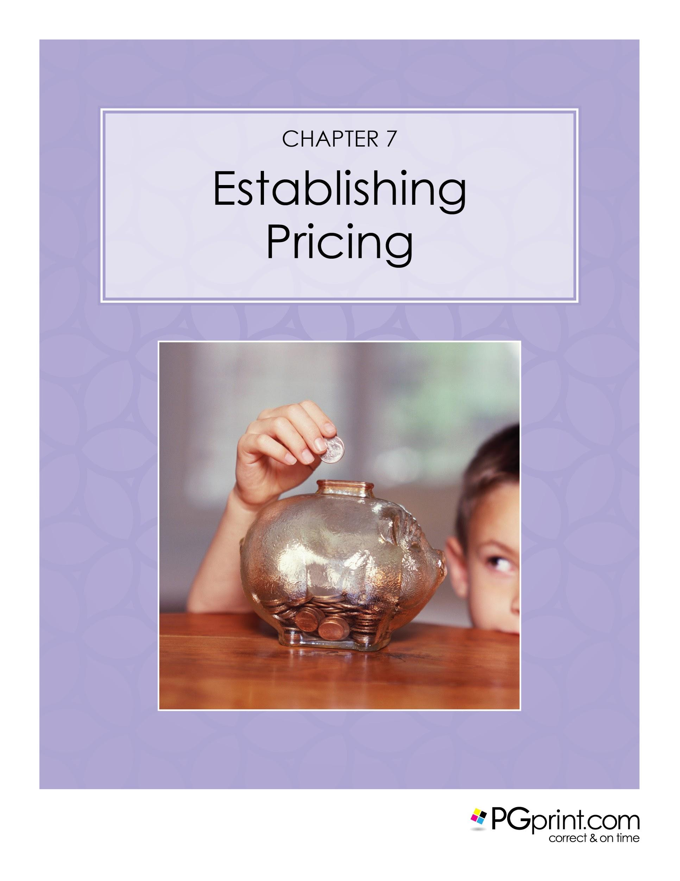

Chapter 7. Establishing Pricing
There are many factors that should be considered when deciding how much you should charge for your babysitting services. Hourly rates for babysitters vary widely depending on your geographical location and the cost of living for your area. Find out the current minimum wage for your state, as this is helpful in determining a base rate. Here is a list of some additional factors that will affect the rate of pay you expect to receive:

- Your age, past experience, and special training or certifications
- Number of children
- Age of children
- Time of day/Day of week/Holidays
- Special needs, requirements, or requests
- Transportation costs

Do some research on your own to see what other sitters are charging in your area. The website babysitting-rates.com advises that “not surprisingly there is no one set babysitting hourly rate for all cases” (Babysitting Rates, 2016). Several websites offer a babysitting rate calculator to help you establish a suggested hourly rate for your location. The website www.Care.com has an excellent babysitter base pay calculator based on your location, and will calculate suggested pay rates by the hour, week, month, and year. The rates shown on any babysitting websites are suggested rates, and you are ultimately responsible for determining what to charge each client based on your knowledge and experience and a prospective client’s needs.

Each babysitting job that you are considering or have already agreed to take may have expenses that will come out of your pocket. For example, transportation costs like bus fare, taxi fare, or gasoline and mileage if you provide your own transportation. You should decide and agree in advance with your client if these costs are included in your babysitting rate or if they will be reimbursed by the client. Sometimes an unexpected expense may arise while you are at a babysitting job. If your client has ordered a takeout meal to be delivered or picked up while you are babysitting and they have not left enough money to cover the cost, how will you handle this? Always be as prepared as possible for situations that may require you to go above and beyond what you had originally contracted for, which includes additional reimbursement to which you may be entitled.

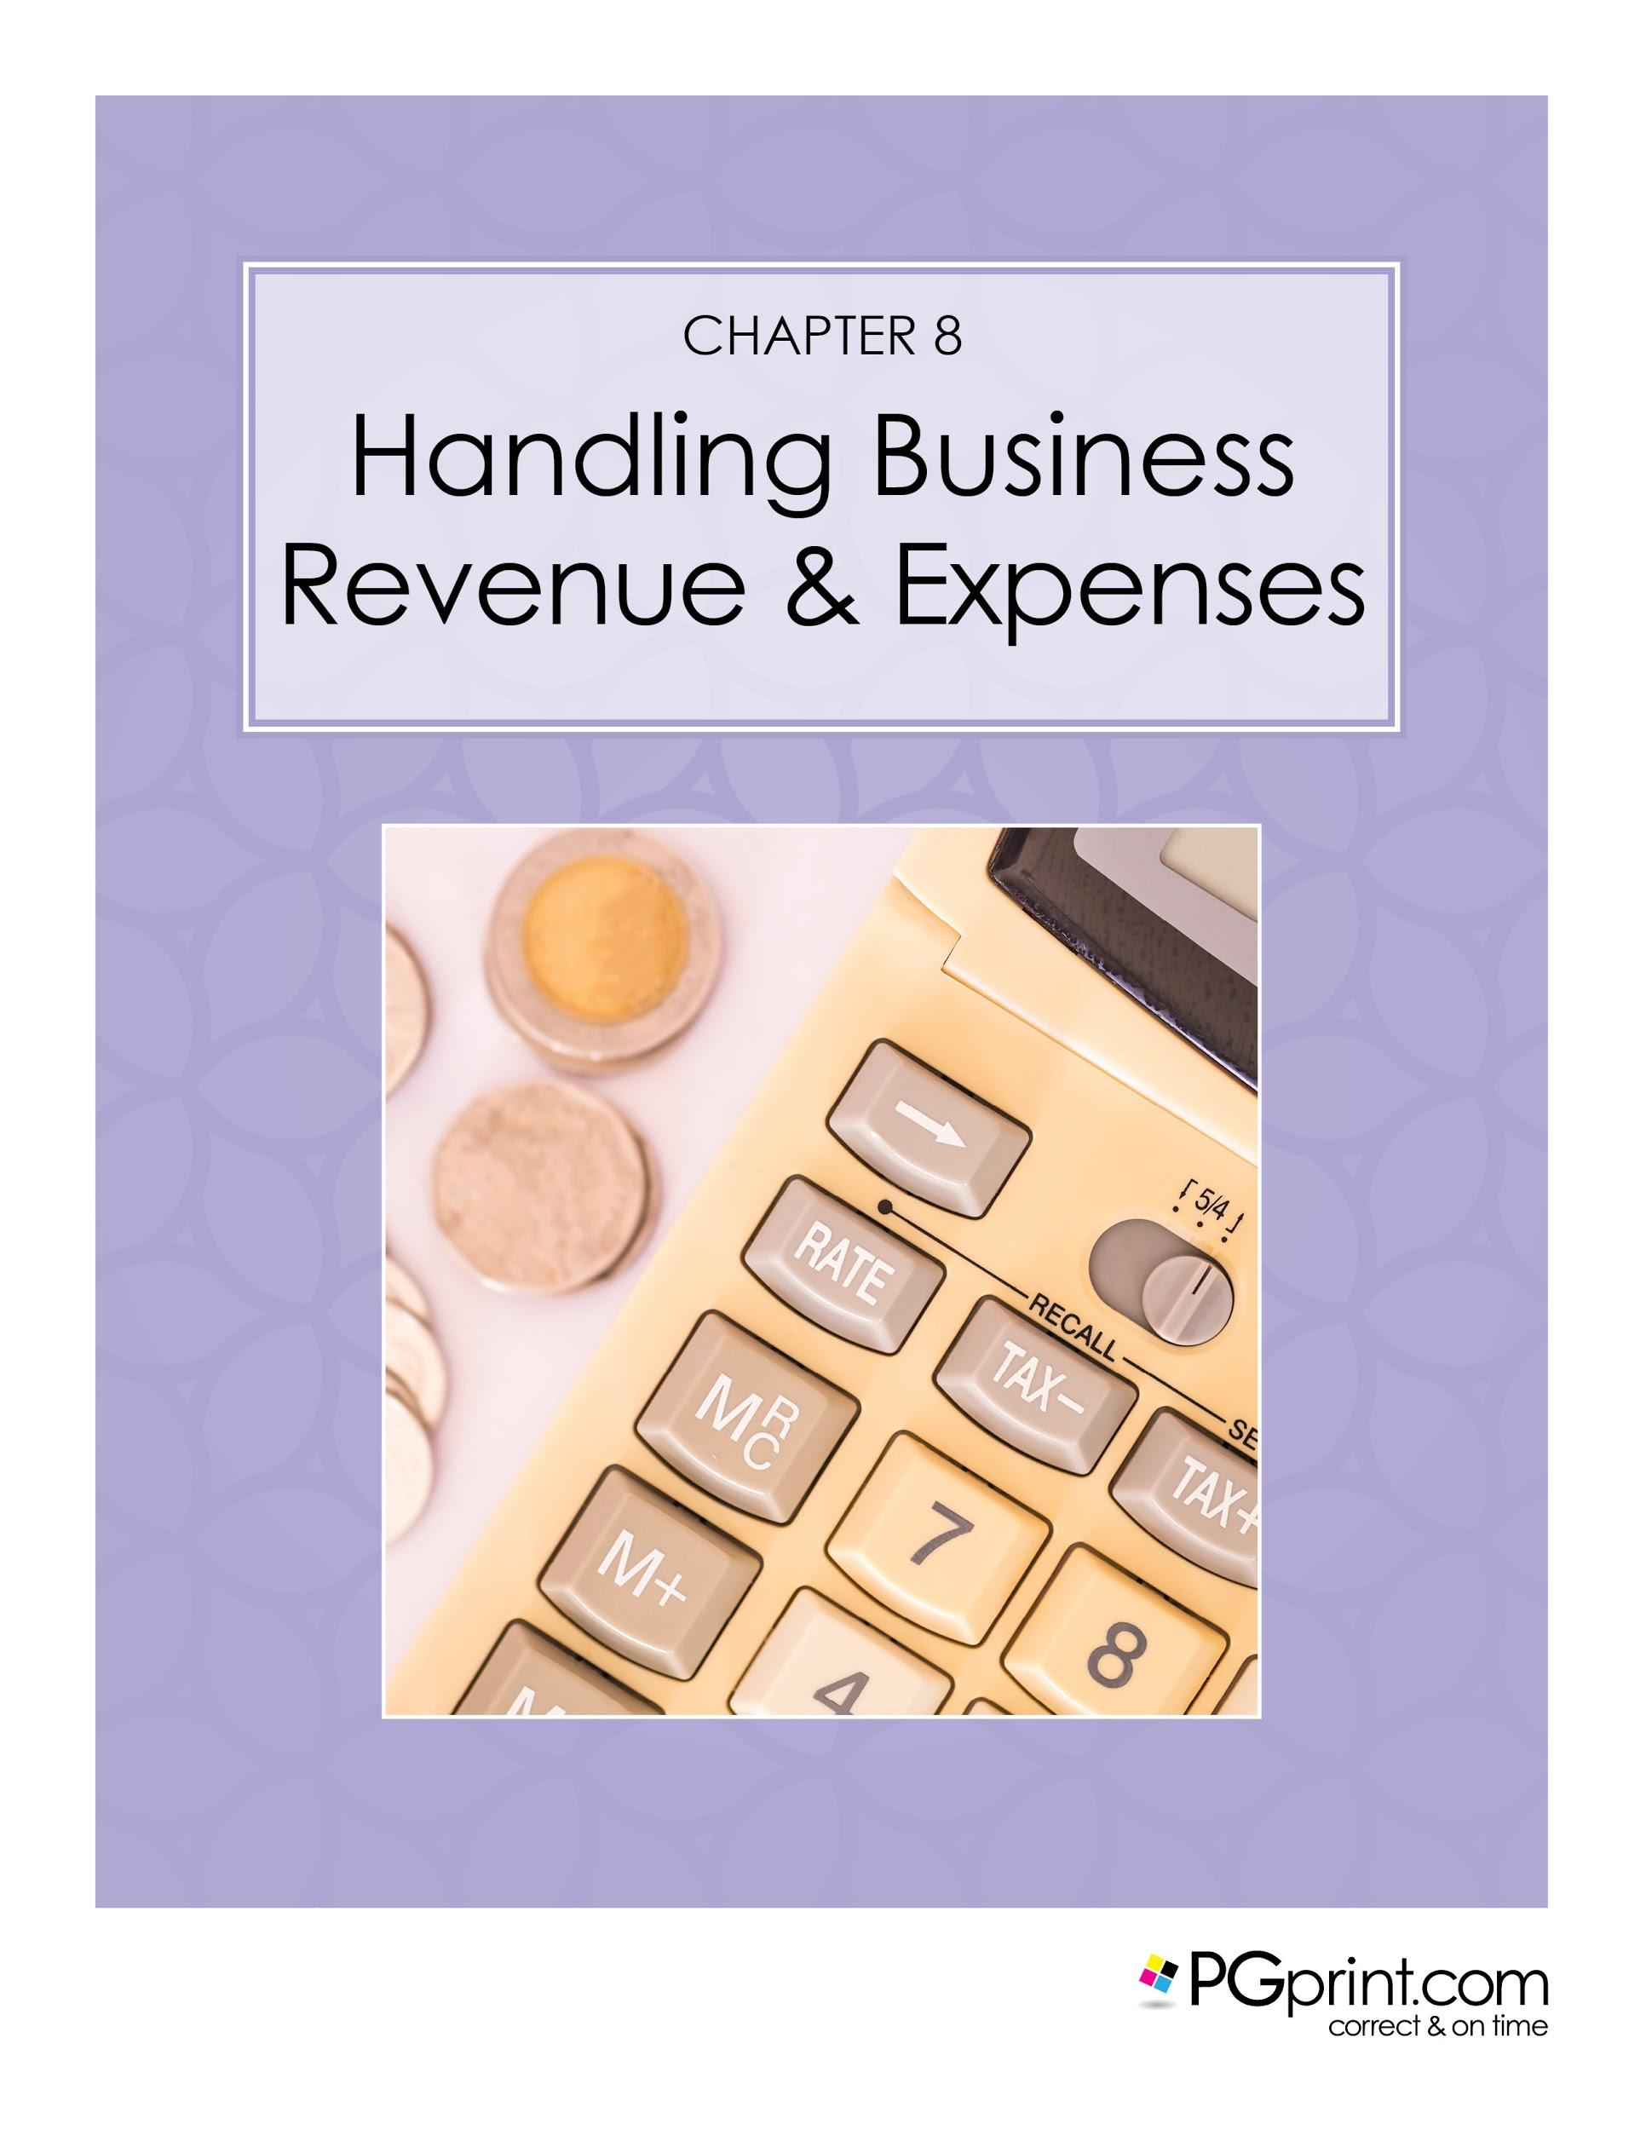

Chapter 8. Handling Business Revenue & Expenses
Set yourself up for success by making sure that you can account for all of the money earned from babysitting as well as keeping track of any and all expenses used solely for your business. This applies to even a small cash-based business. Opening a separate checking account at your bank is advised as it will assist you in keeping track of everything business related that involves money. If you are able and credit worthy, you can also consider getting a new or additional credit card that will be used for business purposes only. Today's technology, when used with bank accounts or credit accounts, can help to streamline the process of credits and debits on your business account by easily categorizing items that were once done by hand. Free online tools are also available that will assist you with money management, budgeting and tracking expenses. The website www.mint.com is just one of the many free online tools available to help you keep track of your business finances.

Chapter 9. Advertising Your New Business
One of the most important ways to generate revenue in any business is to make sure that people know who you are and what you do! Advertising can be as simple as the word of mouth style, letting family, friends, and neighbors know that you have started a babysitting business. With all of the technology at our fingertips today Social Media can be an extremely powerful tool to use to get the word out about your new business. A mix of advertising strategies tends to work well for most babysitting businesses. For most new businesses, your advertising strategy will depend greatly on how much money you can realistically spend to let people know that you are in business.

The best way to begin any advertising of your services or new business is by taking advantage of advertising that is of little or no cost to you. In addition to using word of mouth to advertise, other simple and free or very low cost advertising can be done by printing homemade flyers that can be posted in a number of places. It may help to begin by asking yourself where YOU would notice a flyer for local babysitting services if you were a mother, father or caregiver. If you are a beginner you should also consider what type of prospective client would be in the location where you would be placing a flyer for your services. Bulletin boards at places like your local library, church, grocery store, gym, or daycare center are good places to advertise using a flyer. You may want to leave several at each location. Find out about any local children's events or shows that you can attend and leave printed material if you are allowed. Business cards are another very inexpensive way to promote yourself. Keep some business cards with you at all times as you never know when an new opportunity will present itself.

Instagram is a great way to connect with people and spread the word about your new business. Just like other forms of advertising, keep in mind that you will want to make sure you are reaching your target audience. In Chapter 11, we have listed some of the top US based websites for babysitters, many of which have job posting and opportunities. Be advised that many babysitting websites do charge a fee for ads or membership, much like you would pay for a newspaper ad. There are many choices when it comes to advertising and marketing and ultimately you will decide what you are most comfortable with.
Social media is an extremely powerful way to quickly and effectively advertise your business and has become the norm for businesses both large and small. Advertising on the internet, like other mediums, can be a very inexpensive way to network very quickly using Facebook, Twitter, and Instagram.

Babysitter Flyer Templates
Included in The Ultimate Babysitters’ Guide are additional source files and templates for your babysitting business advertising needs. You can download a template that appeals to you and simply print the fliers out at home, filling in the blanks with your Babysitting details.

Here are a few flyer templates from The Ultimate Babysitting Kit. Simply print the page below and fill in your details!

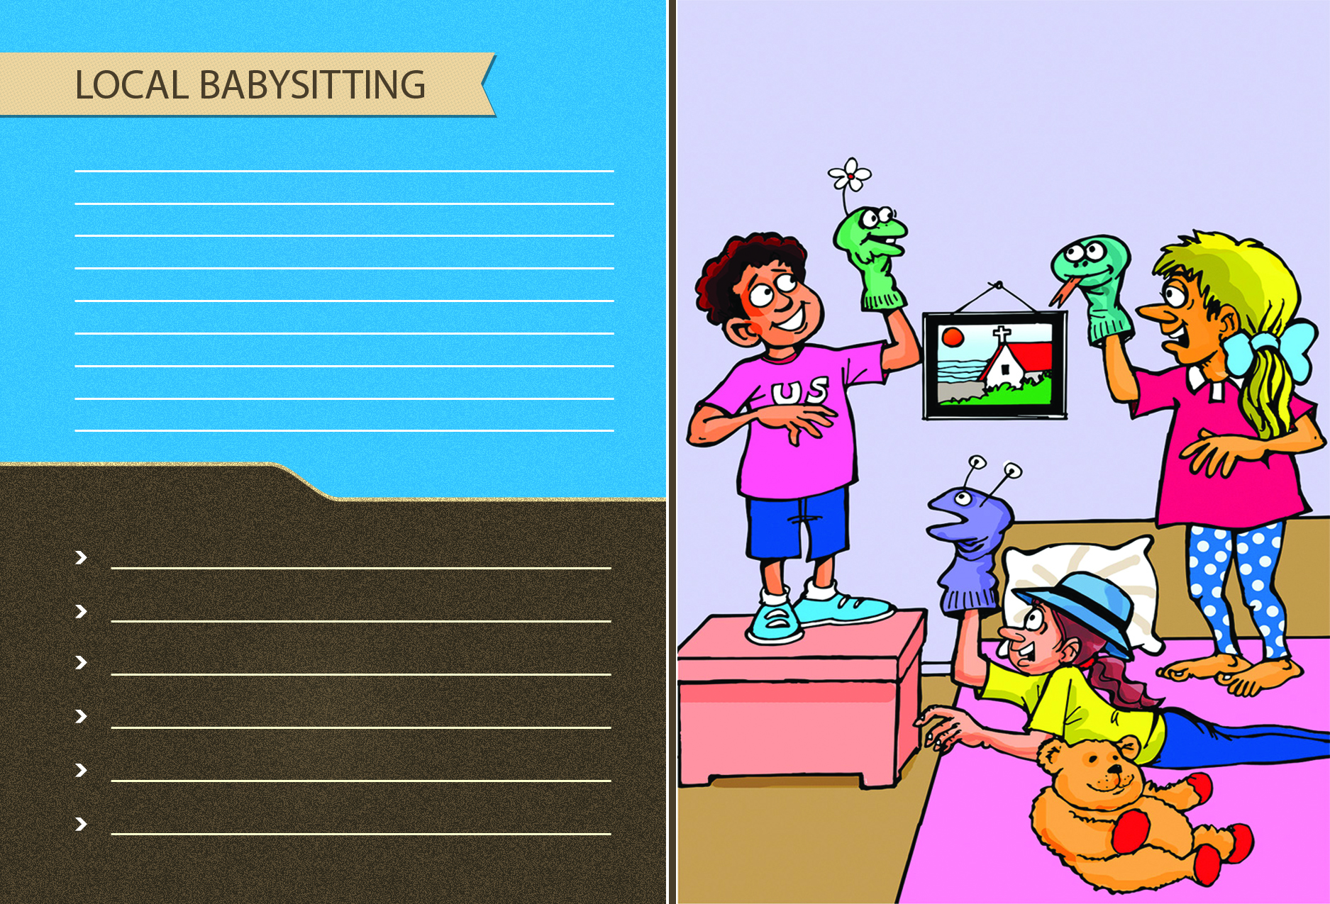

Babysitter Postcard Templates
Using postcards is another cost effective way to advertise your services. While it is illegal to place a postcard in someone else’s mailbox, if you wanted to avoid postage you can wedge your postcards between the mailbox flag and the mailbox itself. As with the flyers above, simply print out the following pages and fill in your details.

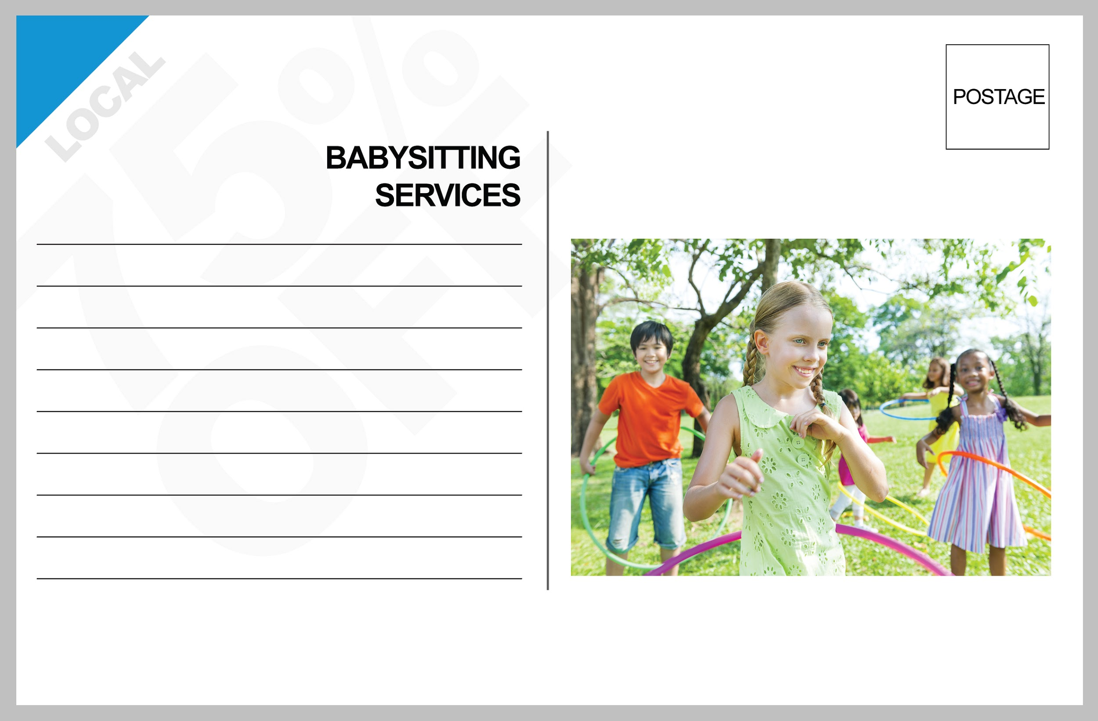

Babysitter Business Card Templates
Unlike advertising with Flyers or Postcards, using Business Cards for your babysitting services allow you to have a more direct interaction with customers. Never simply leave your business card somewhere and assume people will call. Business cards go great with a handshake and an introduction, and truly are one of the most effective ways of getting new clients!

Babysitter Brochure Templates
Brochures can be highly effective if used properly. However, the additional printing and heavier paper can often mean that brochures are a bit pricier than other advertising methods. That being said, there are times when brochures are a must and if you are planning on having a booth at a local trade show or fair, you’ll want to make sure you have some on hand.

PGprint.com has some of the best pricing available on brochure printing, but you can use our templates below free of charge. As with the templates above, simply print and fill in your details.

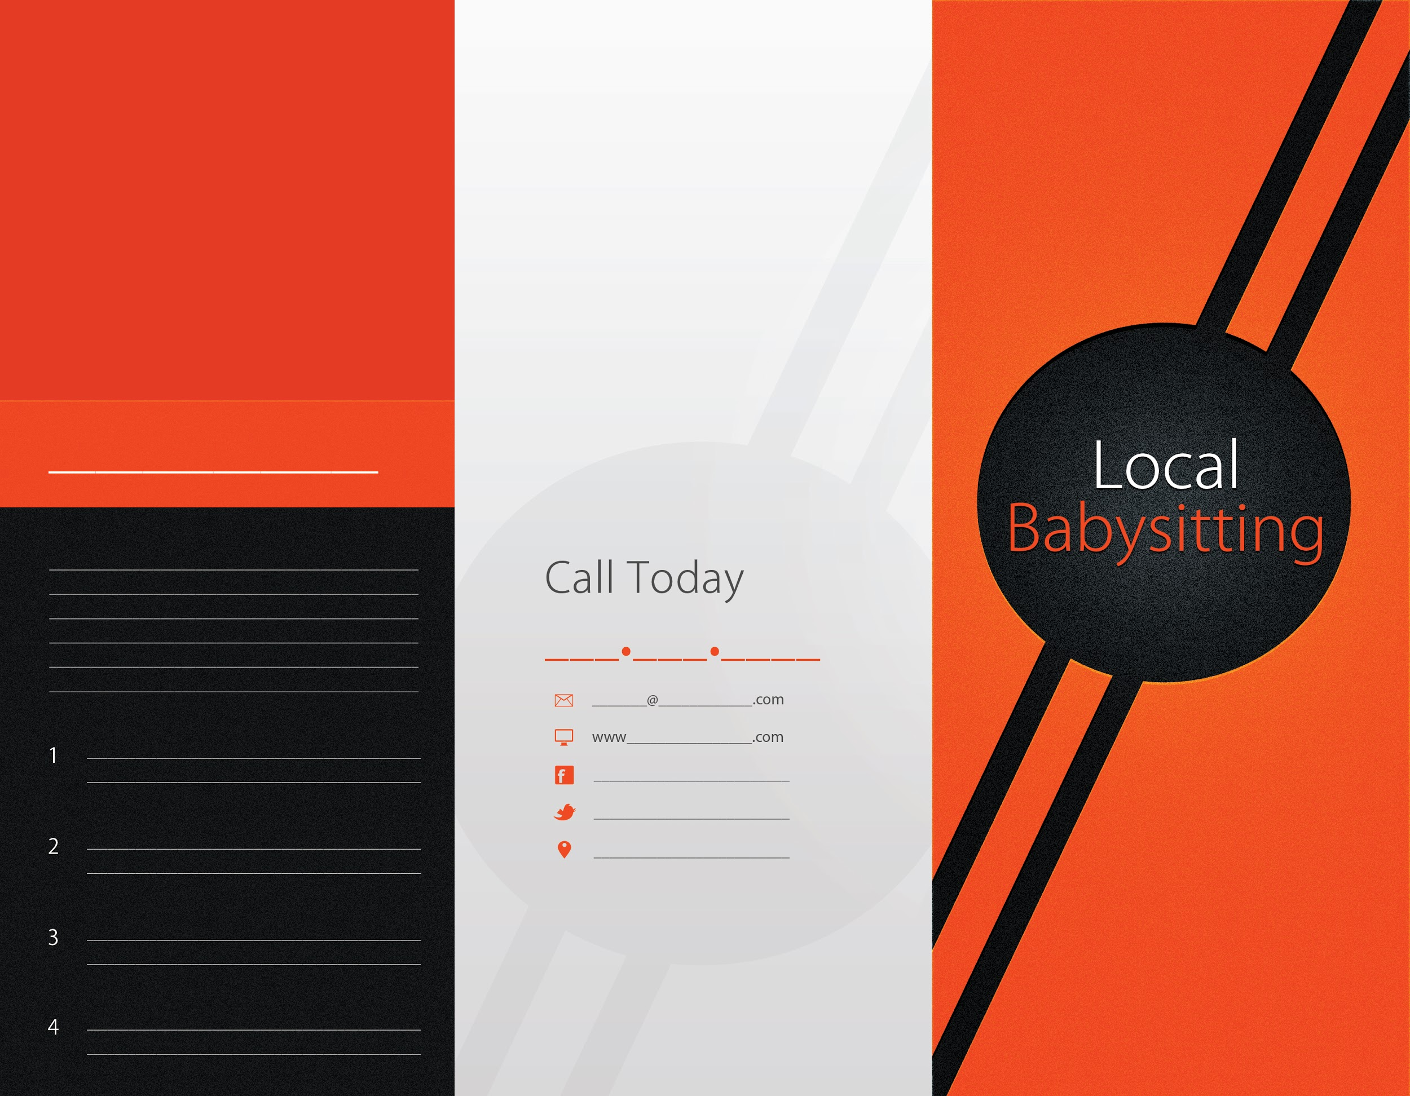

Chapter 10. Dealing With Potential Clients
As you begin interviewing potential clients for a babysitting job, they are interviewing you at the same time. It is important to keep in mind that many times a parent or caregiver will be making their decision about you based on how their child or children react to you and how you interact with them. Asking the right questions before you even accept a job will not only make your job easier, it will ensure that the expectations of both you and your client are clear and understood by all.

Your first interview with any prospective client is the most important. Even though you may know them on a personal level, this might be the first time that they are “meeting” you on a professional level. As always, be prepared! Using a checklist of questions to ask will ensure that you will not miss any significant information that is of importance to you when making your decision on whether or not you should accept a babysitting job. You might feel that some of your first interviews for babysitting jobs may not require such lengthy information. Only you will know when and what to ask depending on each individual situation. Your checklist will help you to move along in the interview process even if you do not need to fill every single line item out to completion. Templates are available to assist you in making sure that you have covered all of the required information to make an informed decision.

Some of the most basic information to gather is:

- How many children will I be responsible for and what are their ages?
- What additional services will I need to provide, i.e., cooking meals, helping with homework, housework, bedtime routines?
- What are the basic house rules for visitors, television, computer time, telephone use and clean up?
- Do any of the children in the house have any medical conditions or medication that they take regularly?
- Are there any family pets that I will be responsible for?
- Are there any favorite activities that your children especially enjoy?
- What type of discipline do you use, and what type of discipline would you like me to use?

These are just a few of the many questions that you should ask in an interview with prospective clients. Although it may seem overwhelming at first, should any issues arise at a job you will be well prepared to handle almost any situation. Your ability to communicate with your clients is extremely important and should never be overlooked. One thing you should NOT do is to monopolize the interview. Your questions are important, but your customers will have questions as well. Remember to actively listen and take notes when necessary, but remain engaged with your prospective client at all times.

The Ultimate Babysitter’s Business Kit also includes a guide to the most common concerns and objections you will face when dealing with parents that are unsure about hiring you as a care provider.

Common Parental Roadblocks and Concerns
- Choosing right daycare
- Tips for preparing your child to stay home alone
- Child care costs
- How to choose cc provider
- Daycare vs in-home
- Teenager pros and cons
- Is my child old enough to stay home
- Things to discuss with child care provider
- Preparing your child for daycare top tips
- Child care costs and options

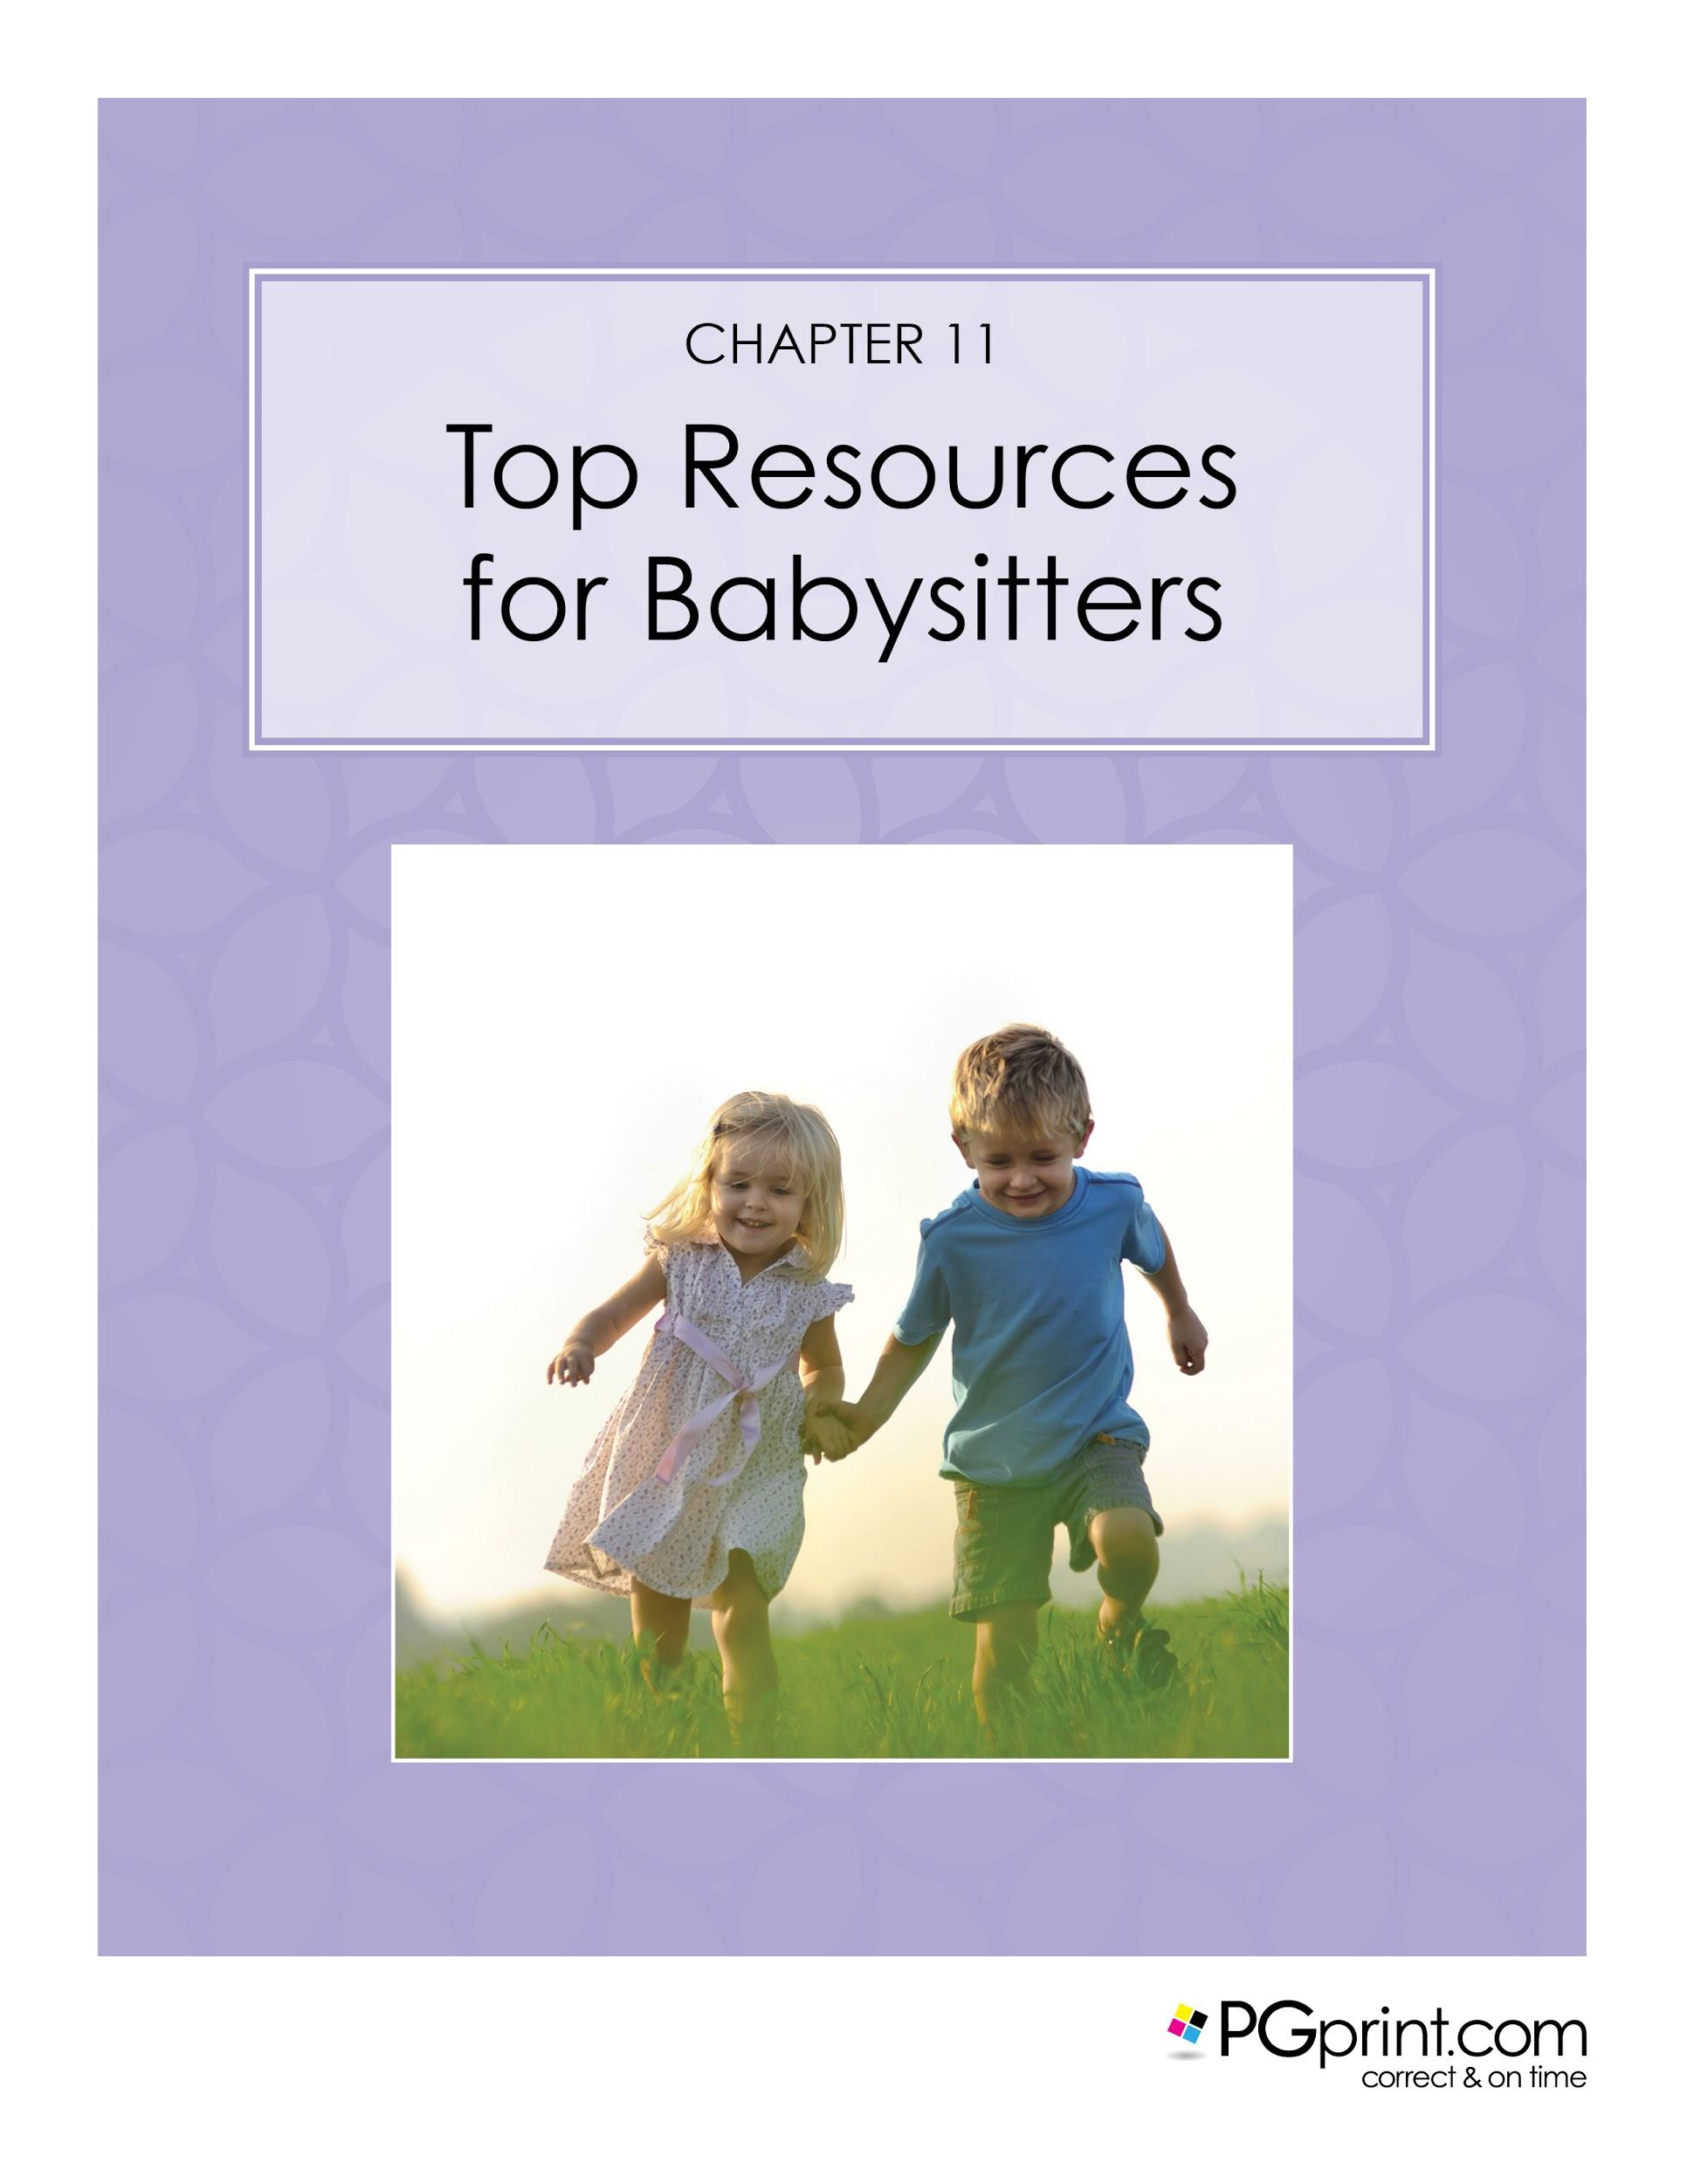Chapter 11. Top Resources for Babysitters
With so information available at our fingertips, it is easy to get lost in a sea of tips and tricks for babysitters who are either looking to begin a new career or start a new business. Listed below are some of the top babysitting websites for the United States that were reviewed and ranked by www.No1Reviews.com. Their site includes a full review of each website listed, including user reviews and related costs that many of the top babysitting websites charge for premium memberships. Free registration is available on almost every babysitting website which will provide you with a wealth of information including useful tips, educational articles and message boards.

- Sittercity
- Great Au Pair
- AuPair.com
- Care.com
- Au Pair Net 24
- Go Nannies
- eNanny Source
- Nanny Pro
- Easy Au Pair
- Nanny.net

Chapter 12. Other Babysitting Ideas and Related Markets
In addition to the traditional babysitting business which involves the care of children, there are also other types of babysitting jobs and businesses that you may decide to pursue exclusively or perhaps add to your current child care business. Here are a few options that you might consider:

- Mother's Helper
- Elder Care
- Senior Companion
- House Sitting
- Plant Sitting
- Pet Sitting
- Day / Summer Camps

Whether you decide to start small or take the plunge into the babysitting business head on, there are many roads and options available to you today. Whatever your ultimate goals may be, your success and profit are truly obtainable. Always remember to treat your business like a business and success can be yours.

Other things you can consider that will help you increase your income.

- Re-evaluate your schedule - setting a schedule, the need for a schedule, how to avoid scheduling problems, what to do when scheduling problems occur was already covered. But, there are always ways you can do more within the same time period.
- Safety checks, what are they and why are they needed. How to do them, why to do them - also covered. However, if you make that a key selling point, you can justify charging more per hour!
- Reevaluate how much to charge, determining your rate, fair fees, expense reimbursements, etc. As your experience grows, don’t forget to charge accordingly.
- Mastering the babysitter interview - tips /tricks, what not to do. Best advice from experts will put you in a position of confidence, able to negotiate.
- Give yourself a promotion and change from a babysitter to a nanny. Pros and cons, how to, why should you - people pay more for titles!
- Professional certifications, what are they, are they needed, where to get them, etc...never stop growing in your profession.

Other areas you can specialize in include:

- Safety training
- Infant Care training
- Water safety and lifeguard training
- Babysitter training
- Babysitting rate calculator
- Childcare for children up to 1 year
- Child care for children 1 - 5
- Child care for children 5-12
- Child care for teenagers
- Special needs care
- Babysitting regulations by state / country

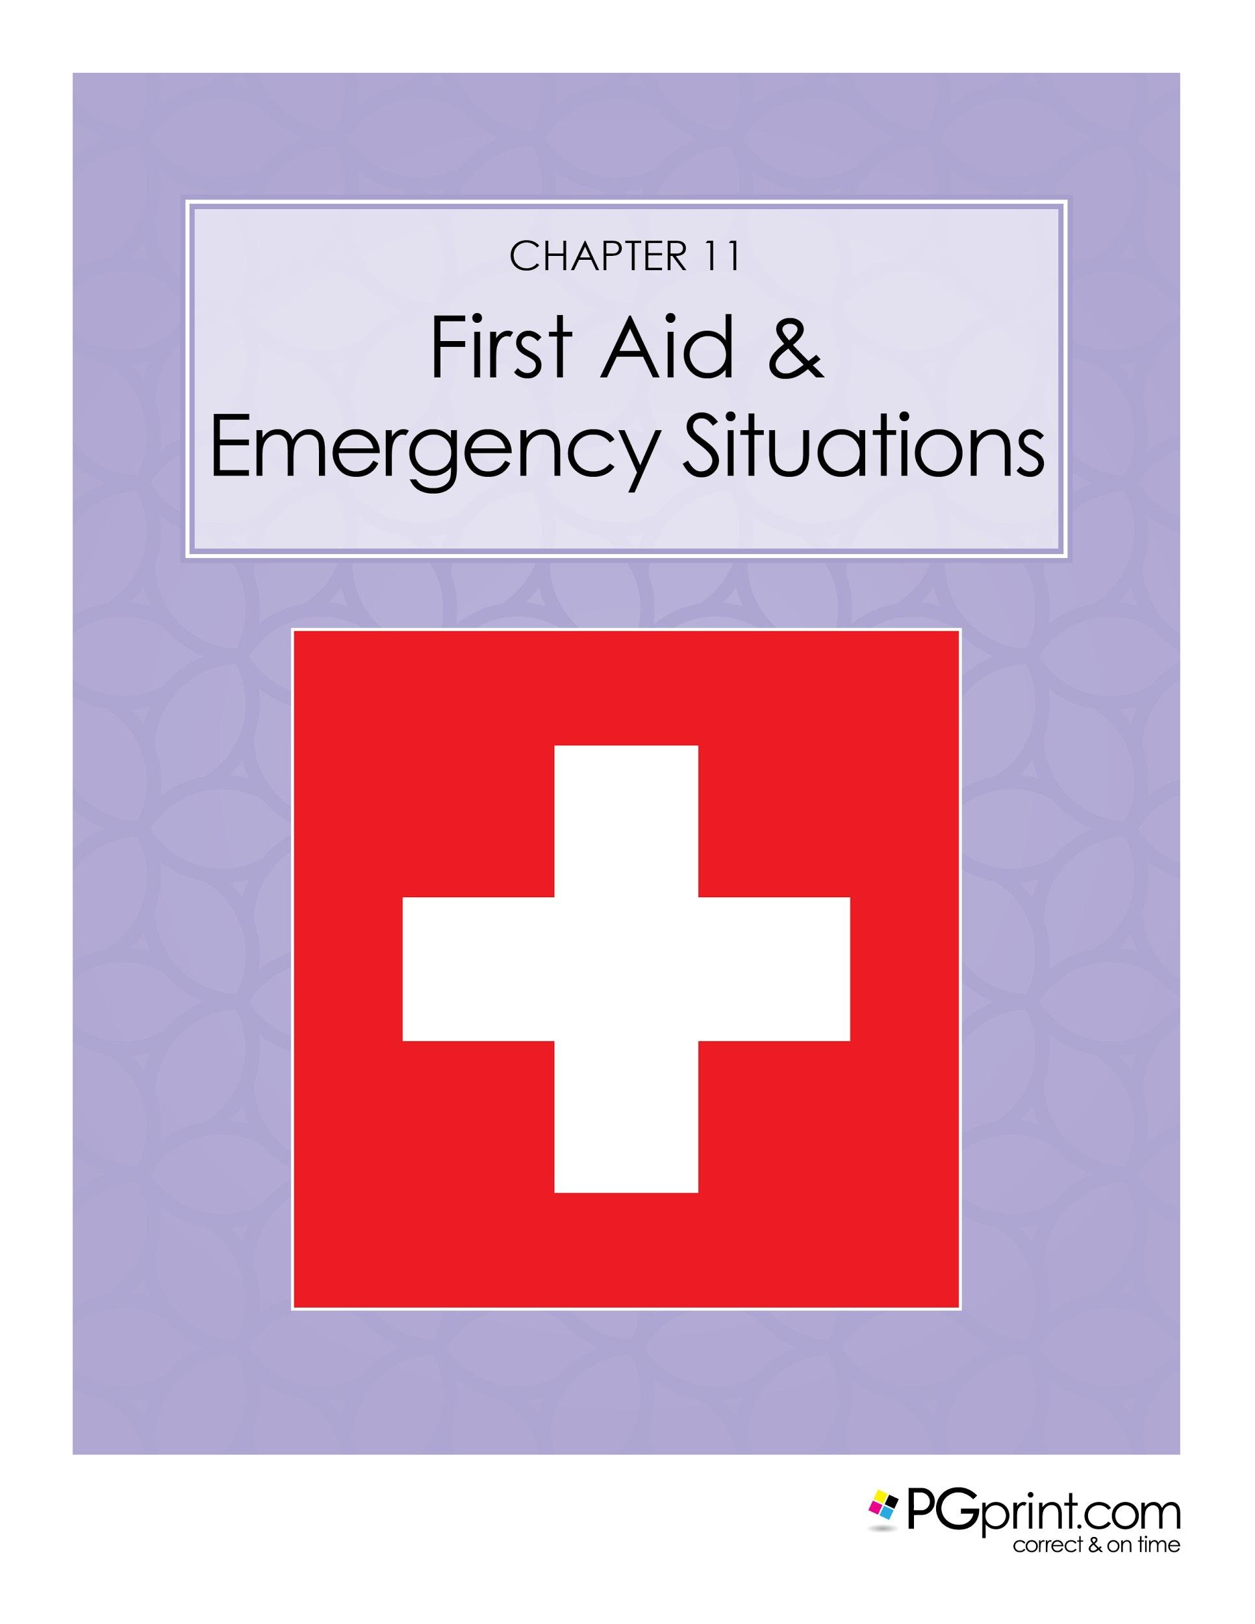

Chapter 13. First Aid and Emergency Situations

As a provider for care, it is your responsibility to seek aid and provide first aid during an emergency situation. Included in The Ultimate Babysitters’ Guide, is a full host of first aid and emergency situation response guidance and printable materials. Here are a few examples that can serve as a quick go-to guide when needed. Visit www.firstaid-cpr.net for more information and source material.

EXTERNAL BLEEDING
Definition: This is where the blood vessels and the skin are cut and blood is escaping the body.

- Causes: Damage to the skin caused by trauma. Can be a laceration (clean cut), abrasion, or avulsion (with skin still hanging).
- Helping: If it’s a minor bleed allow some bleeding to take place as this will help clean the wound. Then wash with warm water and soap, apply a dressing to keep it clean, change the dressing every few hours, and monitor for signs of infection.
- If the bleeding is severe then apply the RED principle:
- Rest: Make sure the person is resting so as to decrease the heart rate and blood pressure.
- Elevate: Raise the injured limb above the heart to slow down the bleeding.
- Direct Pressure: Put pressure directly over the wound to help control bleeding, tie the dressing in place. But, do not make the dressing too tight so as to restrict blood flow. Do not remove the dressing. Get medical help.

Notes:
If there is an impaled object do not remove it as this can cause more bleeding. Instead, apply a dressing around the object then tie it in place to control bleeding. Take extra care not to move the object.

An infection has occurred if over the next few hours the wound becomes red, swollen, and fluid is produced. The infection needs to be taken care of before it becomes worse. If it has progressed to the point where the area around the wound is turning dark red or blue, or the blood vessels are changing color, medical help is needed immediately. This is now a life threatening emergency.

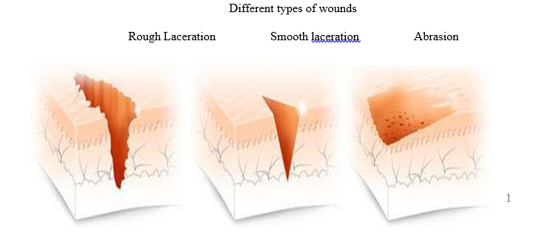

Bandaging:
Bandaging is something you would do to control severe bleeding. Ideally you want to use sterile dressings but they may not be readily available so use whatever you have (e.g. towels, clothing). The idea is to put constant pressure over the cut to control bleeding. You want to tie with enough pressure to control the bleeding but not so much so that blood does not get through to the remainder of the limb. If you restrict blood flow that area may die and may require amputation, so be very careful. Once you’ve tied the dressing you need to check to make sure you did not make it too tight, and check this every couple of minutes. For example, if you’ve bandaged a forearm here’s how you check for circulation:
- Compare both hands to make sure they are similar in temperature and color.
- Check the hand to make sure it is not swelling or turning blue.
- Ask the person if the hand feels numb or tingly.
- If they lose sensation then it’s too tight. Do not remove the bandage but loosen it a bit.
- If the first dressing becomes soaked with blood then simply put another one on top. Do not remove the original one as you will be reopening the wound.

Notes:
Always use caution when dealing with bodily fluids. Wear gloves and wash your hands immediately after. Keep in mind that the injured person may go into shock.
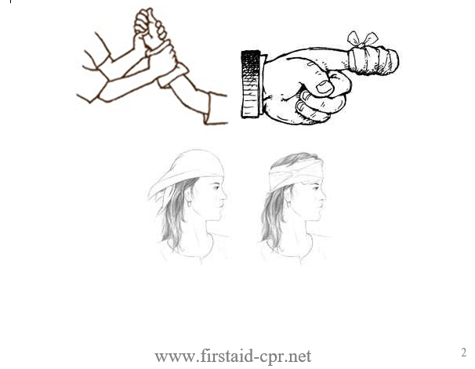

Nose Bleeds:
Have the person rest, have them pinch their nose just below the bone, and lean slightly forward. If the bleeding is severe, if it does not stop in about 10-15 minutes, or if there was an injury to the head or face, medical attention is needed. Do not have the person lean their head back, as all this does is have them swallow their blood, which is not desired.

Slings:
A sling is something you use to keep the hand/arm elevated above the heart and to make it more secure and comfortable for the injured person. It should only be used if it does not cause more pain or discomfort.

INTERNAL BLEEDING
- Definition: This is where the blood vessels are broken but the skin is not, so the person is bleeding under the skin. Injured organs will result in internal bleeding.
- Causes: Usually physical trauma, being hit, falling. Very common in car accidents.
- Warning signs: Bruising, pain, tenderness, mechanism of the injury (what happened).
- There may be blood in their spit, vomit, or urine.

Helping: If it’s a minor bruise on the arm or leg then rest the injured part, apply an ice pack for a few minutes, and watch for signs that it is not healing. If it’s severe internal bleeding in the core of the body then active the ambulance, make sure the person is resting, treat for shock, apply an ice pack, but do NOT put pressure over the wound.

Notes:
Internal bleeding is not always obvious, but can be life threatening. Infection can occur with any wound whether internal or external. If you suspect an infection then seek medical help immediately, as it can become life threatening. Watch out for warning signs such as; the wound is not healing or is getting bigger, discoloration, fluid discharge, and increased pain.

Bibliography

American National Red Cross. (2014). Babysitting & Child Care Training. Retrieved May 24, 2016, from www.redcross.org: http://www.redcross.org/take-a-class/babysitting-child-care

Babysitting games. (2010-2012). Retrieved May 24, 2016, from Babysitting.net: http://www.babysitting.net/babysitting-games/

Babysitting Rates. (2016). Retrieved June 1, 2016, from Learn How Much to Pay a

Babysitter: www.babysitting-rates.com

Fallon, N. (2015, July 16). Want a Professional Reference? How to Ask and What to

Expect. Retrieved June 1, 2016, from Business News Daily: http://www.businessnewsdaily.com/8201-ask-for-professional-reference.html

Kennedy, P. (2008, April 9). 20 Reasons Why You Need a Business Plan. Retrieved May 22, 2016, from Growthink.com: http://www.growthink.com/content/20-reasons-why-you-need-business-plan#ixzz49VCmuxBA

http://www.redcross.org/take-a-class/babysitting-child-care

http://www.businessnewsdaily.com/8201-ask-for-professional-reference.html

http://www.babysitting-rates.com/

